Development Report MELBOURNE HOUSING PRICING

Final version, 17/11/2023

Haiyue Wang - WANHY149  
Pei-Yi Liu (Paggie) - LIUPY023  
Wangjun Shen - SHWY009  
Himanshu Khatri - KHAHY021

Ankur srivastava - SRIAY007

Mohit – MOHMY117

Contents

Abstract. 5

1. Introduction 6

2. Data Summary 7

A. Target Variable 7

B. Predictor Variables 8

C. Data split 9

D Training-Test split. 9

3. Literature Review 10

A. Regression 10

A1. Linear regression: 10

A2. Encoding: 10

A3. Random Forest in Spatial Data Analysis: 10

A4. Gradient Boosting in Spatial Data Analysis: 11

B. Classification 11

B1. Support Vector Machine 11

B2. Artificial Neural Network 11

B3. KNN 12

B4. Decision Tree 15

C. Time Series Analysis 16

D. Bayesian Network 16

E. Clustering 18

E1. Elbow Method 18

E2. K-Means Clustering: 19

4. Methods Transformation, and Results 19

A. Regression 19

Feature engineering 19

Model making 22

Hybrid model. 23

Performance Comparison and Interpretation: 23

Results 24

B. Classification 25

B1. SVM 25

B2. ANN 29

B3. KNN 30

B4 Decision Tree 35

Accuracy Comparison 38

C. Time series 38

D. Bayesian Network 46

E. Clustering 58

5. Summary of Results 65

References 65

Figures

Figure 1 Histogram of Price by Area 7

Figure 2 QQ-plot of Price by Area 8

Figure 3 Histogram log transformed Price by Area 8

Figure 4 Structured outline of proposed methodology 14

Figure 5 Key purpose of decision trees 15

Figure 6 Correlation plot for regression 20

Figure 7 Performance of hybrid model for different weights of random forest and gradient boosting models 23

Figure 8 Correlation Heatmap for Categorical Variables for Different Types of Buildings 25

Figure 9 Correlation Heatmap for Categorical Variables for Different Types of Buildings 26

Figure 10 Correlation Heatmap for Categorical Variables for Different Types of Buildings 26

Figure 11 Correlation Heatmap for Numeric Variables for House Buildings 27

Figure 12 Correlation Heatmap for Numeric Variables for House Buildings 27

Figure 13 Correlation Heatmap for Numeric Variables for House Buildings 28

Figure 14 Correlation Matrix for Houses 31

Figure 15 Correlation Matrix for Townhouses 33

Figure 16 Correlation Matrix for Units 34

Figure 17 Tree for type House 35

Figure 18 Tree for type Townhouse 36

Figure 19 Tree for type Unit 37

Figure 20 Trend of Price by Building Area over the time 39

Figure 21 Trend of Price by Land Size over time 39

Figure 22 ACF and PACF for Log Price by Building Area 40

Figure 23 ACF and PACF for Log Price by Land Size 40

Figure 24 Actual vs Predicted House Prices for model Log Price by Building Area 41

Figure 25 Actual vs Predicted House Prices for model Log Price by Land Size 42

Figure 26 PACF of the residuals of model Log Price by Building Area 43

Figure 27 PACF of the residuals of model Log Price by Land Size 44

Figure 28 Future Predictions of Log Price by Building Size 45

Figure 29 Future Predictions of Log Price by Land Size 45

Figure 30 PDAG of all variables 47

Figure 31 Bayesian Networks graph in house dataset 53

Figure 32 Bayesian Networks in Townhouse Dataset 55

Figure 33 Bayesian Networks in Unit Dataset 57

Figure 34 Elbow method for the optimal number of clusters 58

Figure 35 Property clusters in Melbourne 60

Figure 36 Log Price by area vs DISTANCE by clusters 61

Figure 37 Log Price by area vs YEARBUILT by clusters 61

Figure 38 Log Price by area vs ROOMS by clusters 62

Figure 39 Log Price by area vs BATHROOM by clusters 62

Tables

Table 1 Coefficients and P-values of features in linear regression 21

Table 2 Importance level of all features 21

Table 3 Performance parameters of ensemble regression and hybrid model 23

Table 4 Relative importance of all features of the Hybrid Regression Model 24

Table 5 Performance Metrics of SVM model for Houses 28

Table 6 Performance Metrics of SVM model for townhouses 29

Table 7 Performance Metrics of SVM model for Units 29

Table 8 Performance Metrics of ANN model for Houses 30

Table 9 Performance Metrics of ANN model of Townhouses 30

Table 10 Performance Metrics of ANN model for Units 30

Table 11 Information gain between log_price_level with input features for type House 32

Table 12 Information gain between log_price_level with input features for type townhouse. 33

Table 13 Information gain between log_price_level with input features for type Unit 34

Table 14 Importance between input features with log_price_level for type house 35

Table 15 Importance between input features with log_price_level for type townhouse 36

Table 16 Importance between input features with log_price_level for type unit 37

Table 17 Summary statistics for Decision Tree and KNN 38

Table 18 Model statistics for Log Price by Building Area 41

Table 19 Model Statistics Log Price by Land Size 41

Table 20 Performance indicators for model Log Price by Building Area 42

Table 21 Performance indicators for model Log Price by Land Size 43

Table 22 Causality of all variables 50

Table 23 Causality of House Dataset 52

Table 24 Causality of Townhouse Dataset 54

Table 25 Causality of the unit Dataset 56

Table 26 Overview of three datasets Influential Causality 57

Table 27 Log Price by area statistics in three clusters 59

Table 28 Type of properties in each cluster 60

Table 29 Variable stats of different variables in different clusters 63

# Abstract.

This report conducts a comprehensive exploration of a dataset, utilizing a range of machine-learning techniques for an in-depth analysis. The focus is on examining the interrelationships between variables to achieve accurate property price predictions. Regression analysis methodologies such as Linear Regression, Random Forest, and Gradient Boosting are employed to understand the influence of various features on property prices and to reveal underlying data patterns.

In the realm of classification, Support Vector Machine (SVM), Artificial Neural Network (ANN), K-Nearest Neighbour (KNN), and Decision Tree models are utilized for tasks like property type categorization and selling method prediction. Time series analysis (ARIMA) is applied to comprehend the temporal evolution of property prices, particularly to analyse price fluctuations over time. Bayesian Networks are used to dissect the network of dependencies and causal relationships in the dataset.

Additionally, the report delves into clustering techniques, focusing on K-Means Clustering for data segmentation. This assists in identifying distinct groups within the data, providing insights for targeted marketing strategies and a deeper understanding of Melbourne’s dynamic real estate market.

The report aims to rigorously evaluate the performance of these diverse techniques, offering insights into Melbourne’s real estate market. The goal is to equip investors and analysts with the necessary tools and knowledge for making informed decisions in the evolving industry.

# 1. Introduction

In the dynamic and flourishing real estate environment of Melbourne, the utilization of data-driven insights is essential for making well-informed decisions. The housing market in Melbourne has experienced a significant upswing, and the provided dataset offers a comprehensive exploration of its potential.

This dataset is a rich source of information, including property addresses, types of real estate, suburbs, selling methods, room counts, prices, real estate agents, sale dates, and distances from the Central Business District (CBD). The dataset comprises various specific variables, each with its unique importance:

**ROOMS**: Number of rooms in a property.

**PRICE**: Monetary value of properties.

**METHOD**: Sale method, incorporating different encoded values such as auction or private sale.

**LATTITUDE**: Latitude of the property

**LONGTITUDE**: Obsolete value of Longitude of the property

**TYPE**: Type of real estate, for example, house, unit, townhouse.

**SellerG**: Real estate agent responsible for the sale.

**DATE**: Date of property sale.

**DISTANCE**: Proximity of the property to the CBD.

**REGION**: General region of Melbourne where the property is located.

**PROPERTYCO**: Number of properties within the suburb.

**BEDROOM2**: Bedroom count from an alternative source.

**BATHROOM**: Number of bathrooms.

**CAR**: Available parking spaces.

**LANDSIZE**: Land area of the property.

**BUILDINGAR**: Size of the building on the property.

**COUNCIL**: Governing council of the area.

Covering many vital features, this dataset is an asset for machine learning and predictive modelling. It is useful for a wide range of users, from seasoned real estate investors and aspiring analysts to individuals interested in understanding trends in Melbourne's real estate market. By applying various machine learning techniques and predictive modelling, the dataset aims to forecast property prices, reveal market trends, and support informed decision-making in this rapidly evolving sector. The exploration of Melbourne's real estate market through this dataset aims to chart a course towards successful investment and market understanding.

# 2. Data Summary

A. Target Variable

The target variable in the analysis is the *PRICE* of properties in dollars. The primary objective here is to understand the variations in property prices based on various factors. *PRICE* is a continuous numerical variable, so regression can be used to understand variation in *PRICE* as values of other variables change. The main aim is to build multiple models that can uncover the factors affecting property prices in Melbourne.

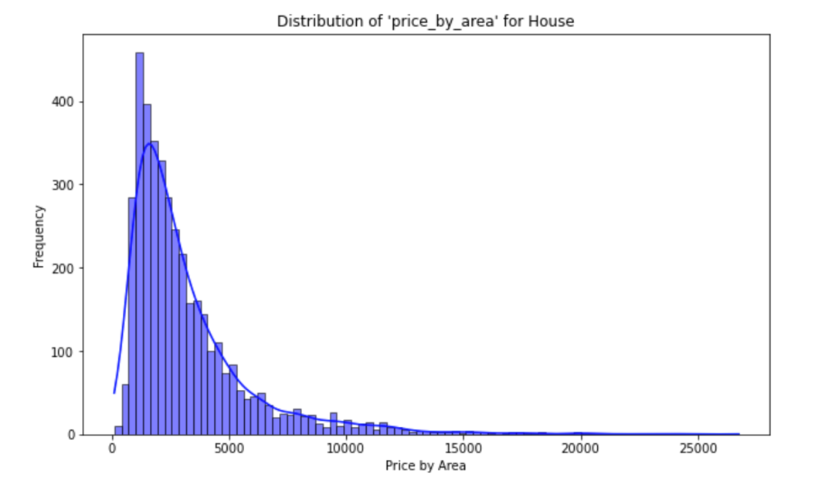

Figure 1 Histogram of Price by Area

The primary target variable here is *PRICE* but it can vary vastly based on the area of any property so for more accurate analysis a new feature called *price_by_area* is created which is *PRICE* divided by *LANDSIZE* for houses and townhouses type of buildings and *PRICE* by *BUILDINGAR* for units as the owner of units lacks the land ownership.

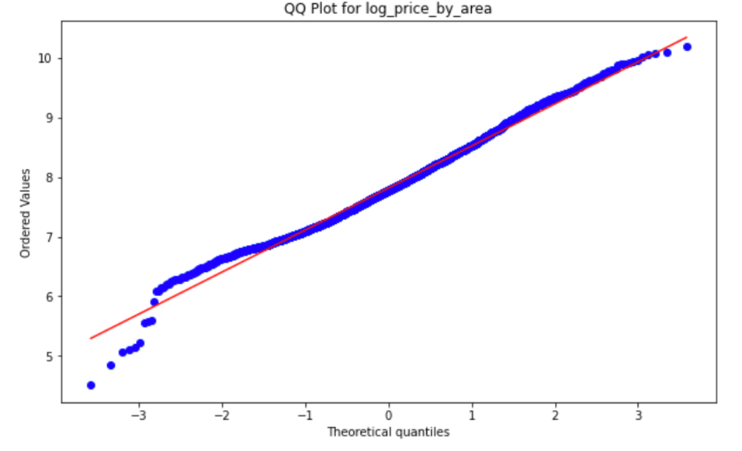

Figure 2 QQ-plot of Price by Area

Additionally, as the data does not exhibit normality, it is further refined by taking the logarithm of *price_by_area*. The new variable is called *logpl* in the dataset. Figure 3 shows the normality of log-transformed *price_by_area*.

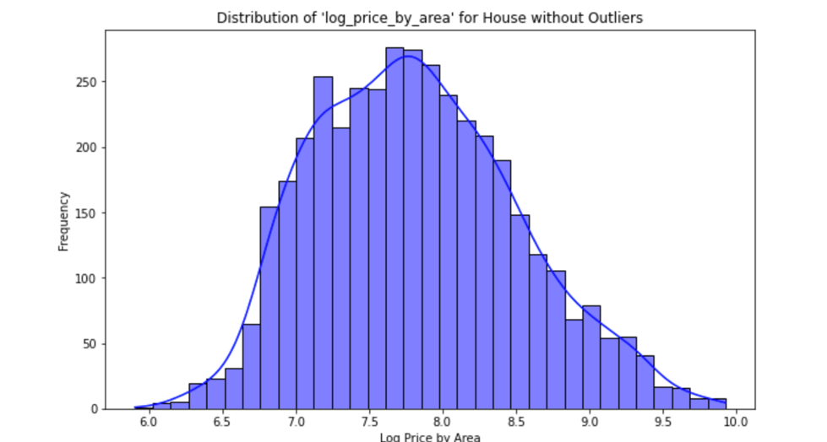

Figure 3 Histogram log transformed Price by Area

## B. Predictor Variables

The predictor variables, also known as features or independent variables, encompass a wide range of factors that may influence property prices. These include the number of rooms, the type of real estate (e.g., house, unit), the suburb's location, the method of selling, the real estate agent involved, the date of sale, the distance from the Central Business District (CBD), and more. These variables are both categorical and numerical, and they hold critical information that can help in uncovering the relationships between different factors and property prices.

In the analysis, Relationships between these predictor variables and the target variable *PRICE* are explored. A variety of machine learning techniques, including regression and classification models, time series analysis, Bayesian networks, and clustering methods is utilized, to extract meaningful insights from this rich dataset. The goal is to build accurate models that can predict property prices, provide market trends, and guide decision-making processes in Melbourne's dynamic real estate market.

C. Data split

A strategic approach is taken in the analysis of the Melbourne real estate dataset by splitting it into three distinct datasets, each focusing on a specific property type: houses, units, and townhouses. The rationale behind this separation lies in the inherent differences among these property types and the need to enhance the accuracy and relevance of the analysis.

One key factor driving this division is the substantial variation in property attributes and features among houses, units, and townhouses. For instance, a house typically has more rooms, a larger land size, and potentially a different pricing structure compared to a unit or townhouse. In this context, combining all property types into a single dataset might lead to skewed results and less meaningful insights.

Another critical consideration is that certain variables, such as *LANDSIZE* and *BUILDINGAR*, may not be applicable or available for all property types. For example, units often do not have individual land areas. To ensure that the analysis is accurate and that the models can learn meaningful relationships, the dataset is separated.

The split dataset is used for classification. Time series and making Bayesian networks. For regression and clustering the dataset yields better results and gives more information when used as a combined set so the combined dataset is utilized for this method.

D Training-Test split.

Throughout the report, a split of **70% training and 30% testing** is used when creating training and testing datasets. This division serves a crucial purpose in ensuring the robustness and reliability of the analysis.

The 70% training data portion is dedicated to building and training the machine learning models. Exposing the models to a significant portion of the data enables them to learn and understand the underlying patterns, relationships, and nuances within the dataset. This extensive exposure is essential for the models to capture the complexities of the real estate market accurately. It allows the models to generalize and make predictions that extend beyond the training dataset, enhancing their predictive power.

On the other hand, the 30% testing data portion serves as an independent evaluation set. It has not been seen by the machine learning models during the training phase. Using this separate set for evaluation ensures that the models' performance is assessed on new, unseen data. This validation process is critical for assessing the models' ability to make accurate predictions on real-world data, which is essential for their practical utility.

The 70-30 split strikes a balance between training data sufficiency and robust model evaluation. If the training dataset were too small, the models might not capture the complexities of the real estate market fully. Conversely, if the testing dataset were too large, the models might not have sufficient data left for training. This division optimally leverages the data available, contributing to more accurate and reliable predictions and ensuring that the results of the analysis are meaningful and actionable.

# 3. Literature Review

## A. Regression

### A1. Linear regression:

Linear regression, often simply termed “regression”, predicts a continuous outcome variable based on one or more predictor variables. Its primary measure of feature importance is derived from the coefficients of the predictors in the regression equation.

The magnitude and sign of the coefficients indicate the direction and strength of the relationship between the predictor and the outcome. However, because these coefficients are scale-dependent, comparing them directly can be misleading, especially when predictors are of different scales. To address this, standardized coefficients (often termed 'beta coefficients') can be used, which represent the change in the outcome for a one standard deviation change in the predictor, making them more comparable (Toothaker, et al., 1994).

The p-values associated with each coefficient inform if the predictor is statistically significant. While this does not directly measure importance, a non-significant predictor is generally considered not to be an important predictor in the context of the other variables in the model (Draper & Smith, 1998).

### A2. Encoding:

One-hot encoding is a fundamental technique used to transform categorical variables into a suitable numerical format for statistical learning. This method is particularly valuable as many learning algorithms require a numerical feature matrix as input. One-hot encoding involves converting each category into a separate binary column, with each category represented by a unique combination of zeros and ones. For example, a categorical variable with categories {female, male, other} can be encoded as {[1, 0, 0], [0, 1, 0], [0, 0, 1]}. This approach ensures that each category is orthogonal and equidistant to the others, aligning with conventional intuitions about nominal categorical variables (Patricio Cerda, 2018)

### A3. Random Forest in Spatial Data Analysis:

Random Forest (Breiman, 2001), is an ensemble learning method that constructs multiple decision trees at training time and produces the mode of the class outputs for classification or the mean prediction for regression. In spatial data analysis, Random Forest has been recognized for its robustness in handling large datasets with missing values, making it apt for applications where data completeness is a challenge.

While the method is not always the go-to technique in geospatial literature, several researchers acknowledge its potential. For instance, (Carranza & Laborte, 2015) highlighted the suitability of Random Forest in geospatial data, noting its capability to handle missing values seamlessly. Moreover, the adaptability of the Random Forest in integrating distances to geological features as predictors demonstrates its flexibility in spatial contexts.

### A4. Gradient Boosting in Spatial Data Analysis:

Gradient Boosting is another ensemble technique, but unlike Random Forest, it constructs predictive models in a stage-wise manner, with each subsequent model being built to correct the errors of its predecessor. This iterative improvement typically results in a more accurate and generalized model, especially with spatial data that often contains non-linear and complex relationships.

The application of Gradient Boosting in spatial data analysis has gained traction in recent years. For instance, spatial autocorrelation, a common phenomenon in geospatial datasets, can lead to overestimation or underestimation in conventional statistical models. Gradient Boosting, with its iterative correction mechanism, can potentially mitigate the effects of spatial autocorrelation (Elith & Leathwick, 2011). Additionally, in land cover classification tasks, Gradient Boosting has been found to outperform traditional classification algorithms, particularly in areas with land cover transitions (Gislason, et al., 2006).

Furthermore, the integration of geospatial features, such as distances to specific landmarks or geographical features, can be intuitively incorporated into the gradient-boosting framework, providing insights into spatial relationships.

## B. Classification

### B1. Support Vector Machine

Support Vector Machine (SVM), introduced by Cortes and Vapnik in 1995 (Cortes & Vapnik, 1995), is a supervised learning algorithm that has proven to be effective in both classification and regression tasks. It works by finding the optimal hyperplane that maximizes the margin between the closest data points (support vectors) of different classes while minimizing the classification error. SVM is particularly useful when dealing with non-linear and complex relationships in data, as it can employ kernel functions to map data into higher-dimensional spaces where linear separation is possible.

In the context of housing price prediction, SVM has gained recognition as an effective tool for modelling and forecasting property values. A study applied SVM to predict housing prices by considering various features such as property size, location, number of bedrooms, and amenities (Jiao, 2017). The study demonstrated the capability of SVM to handle regression tasks effectively, showing competitive performance compared to other regression methods.

There are several reasons why SVM is a suitable choice for predicting housing prices. Firstly, SVM can handle non-linear relationships and complex interactions between features, which are common in real estate markets. Secondly, it allows the integration of geographical and spatial features, such as distance to schools, parks, and public transport, which can significantly impact property values. Finally, SVM's ability to provide a margin of error in its predictions allows for an understanding of housing price fluctuations, which is valuable for real estate professionals and investors.

### B2. Artificial Neural Network

When it comes to house price prediction, artificial neural networks (ANN) have shown quite compelling potential as a machine learning tool. Unlike Gradient Boosting, ANN is a neuron- and hierarchical-based model that makes predictions by learning complex patterns in data.

Research shows that ANN has achieved remarkable results in house price prediction. In predicting the real estate market, the ANN model shows high prediction accuracy. It can process many input features, such as geographical location, house area, surrounding facilities, etc., thereby more accurately capturing the changing patterns of housing prices. Research also points out that ANN performs better than traditional linear models in dealing with nonlinear and complex housing price change patterns (Julia, et al., 2013).

In addition, the application of ANN is not limited to data processing but can also be combined with geospatial features to improve the accuracy of predictions. By incorporating geographical location factors, surrounding environment, and housing characteristics into the ANN model, a more comprehensive housing price prediction can be achieved. This method of comprehensively considering spatial information has shown high feasibility and accuracy in house price prediction tasks (Xiaojie & Yun, 2021).

Overall, ANN, as a powerful machine learning tool, can predict housing prices more accurately, and by integrating geospatial features, the prediction results are more convincing and interpretable.

### B3. KNN

***What is K-Nearest Neighbours (KNN)?***

The purpose of K-Nearest Neighbours (KNN) (Yunneng, 2020) is to make predictions or classifications based on the similarity of data points in a feature space. KNN is a versatile and simple machine learning algorithm used for various purposes, depending on whether it is applied in a regression or classification context.   
Here are the primary purposes of KNN:

* **Classification:** In classification tasks, KNN assigns a class label to a data point based on the majority class among its K nearest neighbours. The purpose is to categorize data into predefined classes or categories. For example, it can be used for image classification, spam email detection, or medical diagnosis.
* **Regression:** In regression tasks, KNN predicts a numerical value for a data point based on the average (or weighted average) of the target values of its K nearest neighbours. The purpose is to estimate a continuous variable. For example, it can be used for predicting house prices, stock prices, or temperature.
* **Anomaly Detection**: KNN can be used to identify anomalies or outliers in a dataset. Anomalies are data points that deviate significantly from the majority of the data. KNN detects anomalies by finding data points with dissimilar neighbours.
* **Recommendation Systems:** KNN can be applied in recommendation systems to suggest items or products to users based on the preferences and behaviours of users with similar tastes. It finds users or items that are nearest in terms of their historical interactions.
* **Clustering:** KNN can be used for clustering data points by grouping them into clusters where data points within the same cluster are more similar to each other than to those in other clusters. It is often used as part of clustering techniques.
* **Imputation:** KNN can be used to impute missing values in a dataset by estimating the missing values based on the values of their nearest neighbours.

However, in this report, the aim is to predict house pricing, while K-Nearest Neighbours (KNN) can be a useful algorithm for creating a model and making a prediction because it leverages the concept of similarity.

***Why KNN Can Build a Model and Predict*** (Yunneng, 2020)***:***

* **Simple to Implement:** KNN is relatively easy to implement compared to more complex machine learning algorithms. It is a good starting point for building a predictive model, especially if you have a limited background in machine learning.
* **No Assumptions About Data Distribution:** KNN does not assume a specific data distribution. This flexibility makes it suitable for datasets where the relationship between features and prices is not well understood or may be non-linear.
* **Customization with 'K':** You can customize the model by choosing the value of 'K.' Smaller 'K' values result in more sensitive models, while larger 'K' values provide smoother predictions. This adaptability is useful when you want to control the model's behaviour.
* **Intuitive Interpretation:** KNN provides intuitive predictions based on the similarity of houses in the dataset. It is easy to understand why two houses with similar characteristics should have similar prices.
* **Use of Feature Engineering:** KNN benefits from feature engineering. You can include relevant features like the number of bedrooms, square footage, and location to make accurate predictions.

***Implement a modelling:***

Feature selection is a crucial step in implementing the K-Nearest Neighbours (KNN) algorithm for house price prediction. It plays a pivotal role in enhancing the quality of the model and improving its predictive capabilities. By carefully choosing the most relevant features, the challenges posed by high-dimensional datasets, often referred to as the "curse of dimensionality" are effectively addressed. This selection of features not only mitigates computational complexities associated with distance calculations but also reduces the risk of overfitting, where the model captures noise in the training data. Moreover, feature selection makes the model more interpretable, simplifying its understanding and explanation to stakeholders. Ultimately, by applying feature selection in the context of KNN, the model is refined, ensuring that it leverages the most informative attributes to provide accurate and efficient predictions for house pricing, thus enhancing its practical utility and effectiveness in real-world applications.

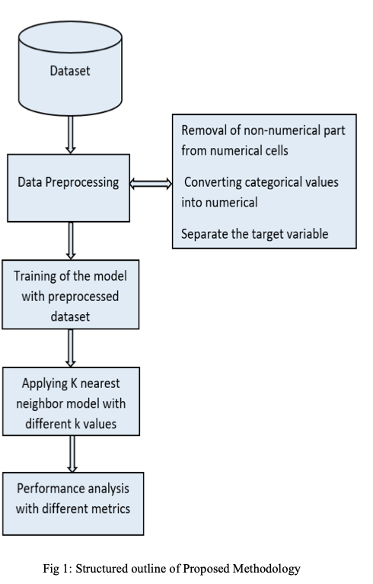

(Samruddhi & Kumar, 2020)

Figure 4 Structured outline of proposed methodology

* **Data Preparation:** Start by collecting and preparing the dataset. The dataset should include features (independent variables) such as the number of bedrooms, square footage, location, and any other relevant information. The target variable is the house price.
* **Feature Scaling:** Standardize or normalize the features. This step ensures that all features contribute equally to the distance calculations in KNN. It is essential because features might have different units or scales.
* **Choosing 'K':** Select the value of 'K,' which represents the number of nearest neighbours to consider when making predictions. The choice of 'K' can impact the model's accuracy and should be determined through techniques like cross-validation.
* **Distance Metric:** Choose a distance metric, such as Euclidean distance or Manhattan distance, to measure the similarity between data points. The distance metric determines how "closeness" is defined.
* **Training the Model:** KNN does not have a traditional training process. Instead, it stores the entire dataset in memory. When you predict a new data point, the algorithm searches for the 'K' nearest neighbours based on the chosen distance metric.
* **Prediction:** To predict the price of a house, the algorithm calculates the average (for regression) of the 'K' nearest neighbours’ prices. The predicted price is the result.

### B4. Decision Tree

A Decision Tree is a popular machine-learning algorithm used for both classification and regression tasks. Its primary purpose is to create a predictive model that can be used to make decisions or predictions based on input features. Decision Trees (Song & Ying, 2015) are structured as a tree-like graph, where each internal node represents a feature or attribute, each branch represents a decision rule, and each leaf node represents an outcome or prediction. The key task for building a decision tree is to split the dataset based on features, the best split could use GINI or entropy to estimate. The decision tree will be established after classifying all datasets or reaching the stop criteria, such as maximum depth.

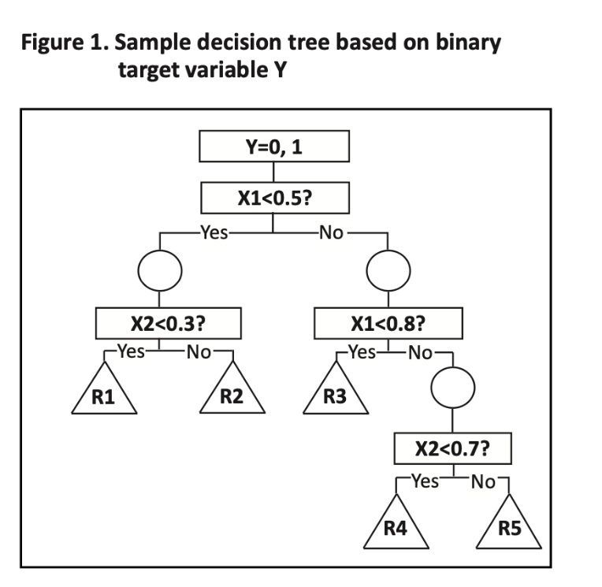

(Song & Ying, 2015)

Figure 5 Key purpose of decision trees

The key purposes of Decision Trees are as follows:

**Classification:** Decision Trees are used to classify data points into predefined categories or classes. For instance, it can classify whether an email is spam or not based on features like sender, subject, and content.

**Regression:** In regression tasks, Decision Trees predict a continuous numerical value based on input features. For example, it can predict house prices based on features like square footage, number of bedrooms, etc.

**Interpretability:** Decision Trees are highly interpretable, meaning their decision-making process is easy to understand. This is crucial when you need to explain the model to non-technical stakeholders.

**Feature Importance:** Decision Trees can provide insights into feature importance, helping you identify which features have the most impact on predictions.

In the context of creating a model and making predictions for house pricing, Decision Trees can assist by providing a model that is relatively easy to implement and interpret. A Decision Tree model can be built using historical housing data, including features like square footage, number of bedrooms, location, and more. The tree structure allows to make predictions based on the values of these features. For example, following the branches of a tree to reach a leaf node that provides a predicted house price. Additionally, Decision Trees (Myles, et al., 2004) can offer insights into which features are most influential in determining house prices, aiding in a better understanding g the housing market dynamics. Overall, Decision Trees are a valuable tool for creating predictive models in the real estate domain.

## C. Time Series Analysis

The ARIMA (Autoregressive Integrated Moving Average) model is a cornerstone in the analysis of time series data, frequently employed for forecasting economic indicators such as housing prices. Its versatility stems from its capacity to model data that exhibit non-stationary characteristics, which is common in economic time series. The "AR" part of ARIMA refers to the regression of the time series onto its past values. The "I" indicates the integration part, suggesting that the data values have been replaced with the difference between their values and previous values to achieve stationarity—a state where the statistical properties of the series like the mean and variance are constant over time. The "MA" part involves the moving average, which models the error of the time series as a combination of past error terms. Technicalities of the ARIMA model include selecting the appropriate order of differencing (d), the number of lagged forecast errors in the prediction equation (q), and the number of lagged observations (p). Selecting these parameters requires careful consideration of the autocorrelation function (ACF) and the partial autocorrelation function (PACF) of the time series. The ACF can help determine the moving average component, while the PACF can assist in identifying the autoregressive component. Model selection is critical as over-differencing can lead to model misspecification, and incorrect parameter choices can result in poor forecast performance. Researchers and analysts often use model fit statistics, such as the Akaike Information Criterion (AIC), to find the most suitable ARIMA model that balances model complexity with the goodness of fit for housing price prediction. (Jadevicius & Huston, 2015) (Crawford, 2003)

## D. Bayesian Network

In this section, the focus is exploring the relationships between variables and identifying the relevant and influential factors that contribute to the overall housing prices in Melbourne. Spanning from July 2016 to June 2017, covering an entire financial year, the goal is to delve into the dataset, assess potential variables, and employ diverse analytical techniques. By emphasizing the exploration of relationships and identifying key influential factors, the aim is to gain insights into the dynamic interactions that shape housing prices over time. This approach will enable to understand the underlying factors that significantly impact the pricing dynamics within the Melbourne housing market.

The purpose of a **Bayesian network** is to model and represent uncertain knowledge in a probabilistic graphical model. It (Neapolitan & Morris, 2004) is used to capture the relationships between different variables and make probabilistic inferences based on available evidence. Bayesian networks are widely used in various fields, including artificial intelligence, machine learning, decision support, and expert systems, to handle uncertainty and perform tasks like classification, prediction, diagnosis, and decision-making. They are particularly useful for modelling complex systems where causal relationships and probabilistic dependencies need to be considered.

***What is a Bayesian Network?***

A Bayesian network (Neapolitan & Morris, 2004) is a probabilistic graphical model that represents a set of variables and their probabilistic dependencies using a **directed acyclic graph (DAG).** It is a way to model uncertainty and make predictions based on available data. In a Bayesian network, nodes in the graph represent variables, and edges represent probabilistic dependencies between them. Each node is associated with a conditional probability distribution that quantifies the probability of the node's value given the values of its parent nodes.

**Bayesian networks** can be useful for several reasons (Darwiche, 2008):

* **Handling Uncertainty:** Housing price prediction is inherently uncertain due to various factors like location, property size, condition, and market trends. Bayesian networks can effectively capture this uncertainty and provide a probabilistic estimate of the price.
* **Incorporating Multiple Variables:** Housing prices depend on numerous factors, including property features, neighbourhood characteristics, economic conditions, and more. Bayesian networks allow you to model these complex relationships and dependencies between variables.
* **Transparent Modelling:** Bayesian networks provide a graphical representation of the relationships between variables, making it easier to understand and interpret the model. This transparency can be valuable for stakeholders and decision-makers.
* **Data Integration:** Bayesian networks can integrate data from various sources, including structured and unstructured data, making them suitable for incorporating diverse information relevant to housing price predictions.
* **Flexibility:** Bayesian networks are adaptable and can accommodate different data types (e.g., continuous, categorical) and variable types (e.g., discrete, continuous). This flexibility makes them suitable for modelling diverse housing data.
* **Updating Predictions:** Bayesian networks allow you to update predictions as new information becomes available. This is particularly important in dynamic markets where housing prices can change rapidly.
* **Prior Knowledge: You** can incorporate prior knowledge or expert opinions into Bayesian networks, improving the model's accuracy, especially in cases where limited data is available.

In summary, a Bayesian network is a powerful probabilistic graphical model that assists in uncovering relationships within variables. It achieves this by representing the probabilistic dependencies among variables in a compact and interpretable graph. The network structure, often depicted as a Directed Acyclic Graph (DAG), reveals direct influences and dependencies, guiding an understanding of the relationships within the system.

In addition, after realizing the Bayesian Network, Causality, Markov blankets, and PC Select are concepts and techniques that are closely related to Bayesian networks.

Bayesian networks are graphical models that represent probabilistic relationships between variables.   
Here are how these concepts are related to Bayesian networks:

* **Causality in Bayesian Networks:**

Bayesian networks are often used to model causal relationships between variables. The graphical structure of a Bayesian network shows the causal dependencies between variables, where arrows represent the direction of causality.

When building a Bayesian network, understanding causality is crucial for correctly specifying the conditional probability distributions that describe how each variable depends on its parents in the network. In Bayesian networks, performing causal inference to answer questions like "What is the effect of changing one variable on another?" This helps in understanding the impact of causal relationships on the network's behaviour.

* **Markov Blankets in Bayesian Networks:**

Markov blankets (Haggstrom, 2018) are important in Bayesian networks for identifying conditional independence relationships. The Markov blanket of a node in a Bayesian network contains the minimum set of nodes that, when observed, renders the node independent of all other nodes in the network.  
Markov blankets are used to simplify the computation of conditional probabilities and likelihoods in Bayesian networks. They help reduce the computational complexity of probabilistic inference in the network.

* **PC Select Algorithm in Bayesian Networks:**

The PC Select algorithm (Tsagris, 2019) is a variant of the PC algorithm, which is commonly used for causal discovery and structure learning in Bayesian networks.

In Bayesian networks, identifying the correct causal structure among variables is essential. The PC Select algorithm helps discover causal relationships between variables from data, enabling the construction of the Bayesian network structure.

The resulting Bayesian network structure can then be used for predictive modelling, as it encodes the probabilistic relationships between variables, facilitating accurate predictions and inferences. In summary, causality, Markov blankets, and PC Select are integral to Bayesian networks because they help model and understand causal relationships, identify conditional independence, and discover causal structures within the network.

## E. Clustering

### E1. Elbow Method

The Elbow Method, a pivotal technique in clustering analysis, plays a crucial role in determining the optimal number of clusters for algorithms such as k-means. This heuristic involves iteratively assessing the within-cluster sum of squared distances (WCSS) as the number of clusters increases. By plotting the WCSS against the number of clusters, the Elbow Method identifies a point where the reduction in WCSS slows down, indicating diminishing returns with additional clusters. Developed as a visual aid to balance model complexity and explanatory power, the Elbow Method has historical significance in clustering research. Challenges include subjectivity in identifying the "elbow" and sensitivity to dataset characteristics. Alongside the silhouette score, the Elbow Method provides insights into clustering quality, aiding practitioners in selecting a reasonable number of clusters for various applications, from image segmentation to customer profiling. As clustering methodologies evolve, the Elbow Method remains an indispensable tool for clustering analysis, contributing to the interpretability and effectiveness of unsupervised learning approaches (Syakur, et al., 2018).

### E2. K-Means Clustering:

K-means clustering is an unsupervised learning algorithm used for partitioning a dataset into a set of k groups (or clusters), where k is a predefined number. It works by assigning each data point to the nearest cluster centre, which is determined based on the mean values of the points in the cluster. The algorithm iteratively adjusts the positions of the cluster centres to minimize the variance within each cluster. This process continues until the positions of the cluster centres stabilize, meaning they no longer change significantly, resulting in a set of homogeneous clusters with data points grouped based on similarity. (Lam, et al., 2015).

# 4. Methods Transformation, and Results

## A. Regression

In the analysis of the Melbourne housing dataset, the type of property is a categorical variable that significantly influences the price (*logpl*). Instead of splitting the dataset into three separate sets based on property type and analysing them independently, the *TYPE* variable is integrated into the model as a numerical predictor through encoding. This approach allows for a unified model that captures the variations in *logpl* across different property types within the same regression framework. By including *TYPE* as a factor in the model, its impact is accounted for while also leveraging the full range of data available. This method enhances the robustness of the analysis by:

* Utilizing a larger dataset, which can lead to more accurate estimates of the model parameters.
* Avoiding the complexity and potential biases that may arise from building and maintaining multiple separate models.
* Allowing the model to identify and learn the interactions between property type and other features, potentially uncovering insights that separate models might miss.

### Feature engineering

At first, a regression model is made after analysing the correlation in-between the target and predictor variables.

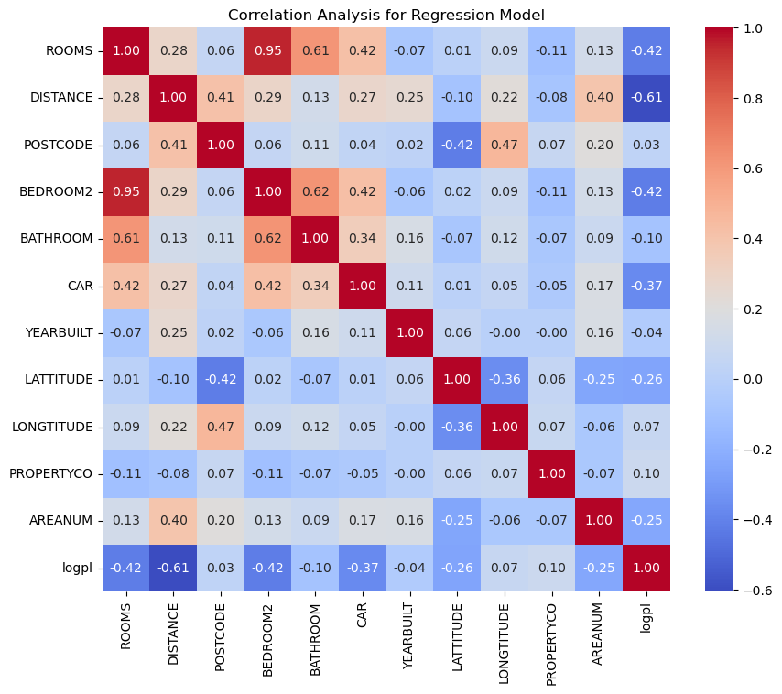

Figure 6 Correlation plot for regression

In Figure 6, *ROOMS, DISTANCE, BEDROOM2, CAR, LATTITUDE,* and *AREANUM* show a good correlation with the target variable.

In addition to that variables *BEDROOM2* and *ROOMS*, *LONGTITUDE* and *POSTCODE*, *ROOMS,* and *CAR* show strong collinearity among themselves.

A linear regression is fitted to the dataset to find the significance of variables. The regression model yields an R2 of 0.61. In cross-validation, the mean MSE is 0.232 and the standard deviation is 0.018.

The significance of the numerical variables is as follows.

|  |  |  |
| --- | --- | --- |
|  | **Coefficient** | **P-Value** |
| const | -131.834 | 1.05E-36 |
| ROOMS | -0.13603 | 1.02E-10 |
| DISTANCE | -0.08367 | 0 |
| POSTCODE | 0.001649 | 8.62E-69 |
| BEDROOM2 | -0.08192 | 0.000103 |
| BATHROOM | 0.159209 | 1.34E-40 |
| CAR | -0.1175 | 4.33E-54 |
| YEARBUILT | 0.002123 | 1.08E-31 |
| LATTITUDE | -2.29499 | 9.9E-119 |
| LONGTITUDE | 0.313022 | 2.89E-05 |
| PROPERTYCO | 1.59E-06 | 0.273303 |
| AREANUM | -0.02371 | 5.35E-11 |

Table 1 Coefficients and P-values of features in linear regression

As seen in Table 1, all features except *PROPERTYCO* are significant so *PROPERTYCO* is discarded for all further analysis. The feature importance level of all remaining variables is analysed using a random forest regressor. In addition to the numerical variables, the variable *TYPE* is now added as a numerical variable by encoding it into type_h, type_t, and type_u representing houses, townhouses, and units, respectively.

|  |  |  |
| --- | --- | --- |
|  | **Feature** | **Importance** **level** |
| 1 | DISTANCE | 0.363249 |
| 2 | type_u | 0.279393 |
| 3 | LATTITUDE | 0.075628 |
| 4 | LONGTITUDE | 0.071703 |
| 5 | YEARBUILT | 0.067997 |
| 6 | type_h | 0.049694 |
| 7 | POSTCODE | 0.030542 |
| 8 | type_t | 0.020609 |
| 9 | CAR | 0.01252 |
| 10 | ROOMS | 0.008343 |
| 11 | BEDROOM2 | 0.008307 |
| 12 | BATHROOM | 0.007938 |
| 13 | AREANUM | 0.004077 |

Table 2 Importance level of all features

For further analysis using ensemble methods, from all the features in Table 2, rather than defining an arbitrary threshold and choosing some top features, all features are chosen to get the best model possible. However, features like *ROOMS*, *POSTCODE*, and *AREANUM* are discarded as they have high collinearity with *BEDROOM2*, *LONGTITUDE*, and *DISTANCE* respectively, and these discarded features were determined to have a lower level of importance compared to the features retained. This decision is based on the understanding that maintaining features with higher importance and less collinearity leads to more effective and efficient models, avoiding redundancy and potential overfitting.

### Model making

Two regression models, a Random Forest, and a Gradient Boosting model, have been developed using identified features. These models are particularly effective for this analysis due to their respective strengths. The Random Forest model is robust against overfitting and is capable of handling non-linear data with high variance. It works well with large datasets and can manage thousands of input variables without variable deletion. On the other hand, Gradient Boosting is known for its predictive accuracy by sequentially correcting the mistakes of previous models and can optimize on different loss functions, making it highly flexible and precise in prediction tasks.

**Random Forest model.**

After trying multiple parameters through grid search, the best model is obtained by splitting the dataset into 30% for testing and 70% for training. The number of trees in the forest is limited to three hundred and other parameters like max_depth and min_samples_split are not explicitly defined, so they are set to their default values as per the Scikit-learn library in Python. The R2 obtained for the fitted Random Forest model is 0.826, which means the model captures 82.6% of variances in the Log of price by area.

**Gradient boosting model.**

The number of boosting stages (trees) to be run, essentially the number of sequential trees being modelled is limited to 300, and other parameters like max_depth and learning_rate are not explicitly defined, so they are set to their default values as per the Scikit-learn library. The R2 obtained for the fitted Gradient boosting model is 0.829.

**Cross-validation:**

Both models are validated using 5-fold cross-validation. The results for both random forest and Gradient boosting are as follows.

For the Random Forest:

* Mean MSE: ≈0.118
* Standard Deviation MSE: ≈0.012

For the Gradient Boosting:

* Mean MSE: ≈0.114
* Standard Deviation MSE: ≈0.024

**Model Performance:** The Gradient Boosting model has a slightly lower mean MSE compared to the Random Forest, suggesting that it has a better average performance in terms of prediction error.

**Model Consistency:** The Random Forest model has a lower standard deviation in MSE, indicating that its performance is more consistent across different folds of the data. The Gradient Boosting model, while performing better on average, shows more variability in its performance.

As one model has better performance while the other has better consistency, combining both models might yield an even better model.

### Hybrid model.

Both Random Forest and Gradient boosting models are combined with the weighted averaging method.

Figure 7 shows different levels of R2 (y-axis) vs the weight of the Random Forest (x-axis).

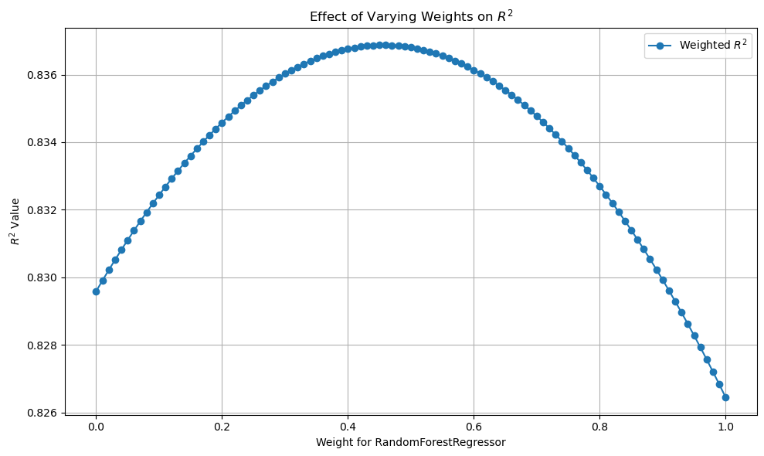

Figure 7 Performance of hybrid model for different weights of random forest and gradient boosting models

Using Figure 7, 0.45 is taken as the weight for Random Forest and 0.55 as the weight for Gradient boosting.

The final hybrid model yields an R2 of 0.837.

Validating the hybrid model using 5-fold Cross-validation on the hybrid model yields the following results.

* Mean MSE: ≈0.099
* SD MSE: ≈0.011

### Performance Comparison and Interpretation:

|  |  |  |  |
| --- | --- | --- | --- |
|  | Random Forest | Gradient Boosting | Hybrid Model |
| MSE | 0.102 | 0.100 | 0.096 |
| MAE | 0.215 | 0.218 | 0.210 |
| R2 | 0.826 | 0.829 | 0.837 |
| 5-fold CV Mean MSE | 0.118 | 0.114 | 0.010 |
| 5-fold CV SD MSE | 0.012 | 0.024 | 0.013 |

Table 3 Performance parameters of ensemble regression and hybrid model

* **Performance:** The Weighted Average Hybrid Model shows a significant improvement over the initial models in terms of the Mean MSE. It has the lowest Mean MSE among the three, indicating that, on average, it predicts with less error.
* **Consistency:** The Random Forest Regressor is the most consistent model with the lowest SD in MSE. However, the Weighted Average Hybrid Model also shows good consistency, with its SD in MSE being close to that of the Random Forest and lower than that of the Gradient Boosting.
* **Error Reduction:** The hybrid model's improvement in Mean MSE suggests that combining the models helps reduce prediction error, potentially by leveraging the strengths of both individual models.
* **Stability:** Despite the Gradient Boosting Regressor's higher variability (SD in MSE), its strengths when combined with the Random Forest in the hybrid model led to a more stable model than Gradient Boosting alone.

In summary, the Weighted Average Hybrid Model appears to offer a favourable balance between error minimization and consistency, outperforming the individual initial models in terms of the Mean MSE while maintaining a reasonable level of variability across different data subsets. In addition to that the Hybrid model also yields an R2 value higher than both Individual models.

### Results

First, the Importance of features in predicting the variance in the target variable is analysed.

|  |  |  |  |  |
| --- | --- | --- | --- | --- |
|  | Feature | Random Forest | Gradient boosting | Mean Importance |
| 1 | DISTANCE | 0.359768 | 0.383445 | 0.371606 |
| 2 | type_u | 0.281138 | 0.197066 | 0.239102 |
| 3 | type_h | 0.050886 | 0.166818 | 0.108852 |
| 4 | LATTITUDE | 0.094765 | 0.100073 | 0.097419 |
| 5 | LONGTITUDE | 0.089964 | 0.074995 | 0.082479 |
| 6 | YEARBUILT | 0.06869 | 0.041698 | 0.055194 |
| 7 | type_t | 0.017458 | 0.019362 | 0.01841 |
| 8 | CAR | 0.014023 | 0.007364 | 0.010693 |
| 9 | BEDROOM2 | 0.014529 | 0.004034 | 0.009282 |
| 10 | BATHROOM | 0.008779 | 0.005145 | 0.006962 |

Table 4 Relative importance of all features of the Hybrid Regression Model

* *DISTANCE*: This is the most important feature in predicting the log-transformed price (*logpl*), with the highest mean importance across both models. It suggests that the distance from the city centre is a crucial factor in determining property prices.
* Property Type (*type_u*, *type_h*, *type_t*): The type of property (unit, house, townhouse) also plays a significant role, with *type_u* that is for units having notably high importance, especially in the Random Forest model. This indicates that the type of property is a significant factor in its price.
* Geographic Location (*LATTITUDE*, *LONGTITUDE*): Latitude and longitude, which represent the property's geographic location, are also important predictors. This aligns with the common real estate mantra of "location, location, location."
* *YEARBUILT*: The year in which the property was built holds some importance, suggesting that newer or older homes might have specific price implications.
* *CAR*, *BEDROOM2*, *BATHROOM*: These features have lower importance in predicting property prices. However, they still contribute to the overall predictive power of the model.

Based on these insights, the following results are derived:

**Proximity to City Centre:** Properties closer to the city centre are likely to be more expensive given the same type, size, and other features.

**Property Type:** Property being a unit tends to have a significant impact on price, possibly due to their popularity or availability in certain areas.

**Location-Specific Marketing:** The importance of latitude and longitude suggests that certain locations within Melbourne are more sought after. Particularly towards the south of CBD.

**New Developments and Renovations:** The year a property was built affects its price. This shows that newer properties are preferred more in comparison to older ones.

**Feature Additions and Renovations:** Features like the number of cars that can be parked have more impact on property prices than the number of bedrooms, which is surprising.

These insights can guide decision-making in the real estate market, from individual property valuations to broader market strategies.​​

## B. Classification

### B1. SVM

**Feature Engineering**

First, the correlation between variables is analysed and variables with significant correlation are removed, thereby reducing the complexity of the model, and avoiding possible multicollinearity problems.

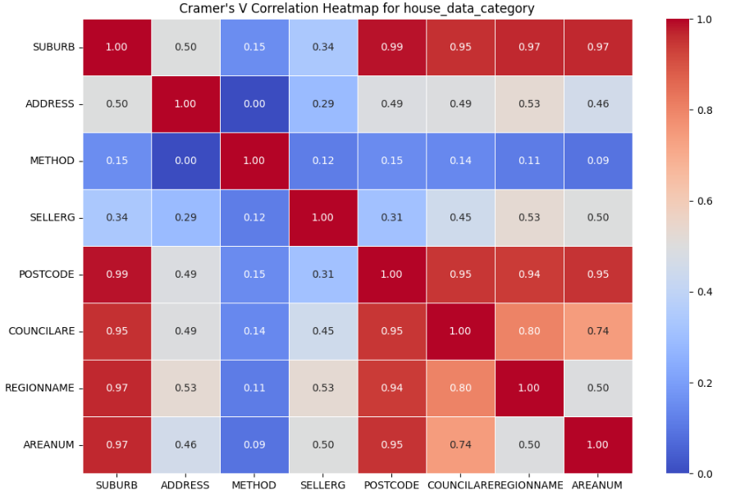

Figure 8 Correlation Heatmap for Categorical Variables for Different Types of Buildings

Figure 8 illustrates the correlation among categorical variables for house data. There is a significant correlation between *SUBURB* and *REGIONNAME*, as well as between *COUNCILARE* and *POSTCODE*, with all correlations exceeding 95%.

Then the correlation between the categorical variables in townhouse data and unit data is checked.

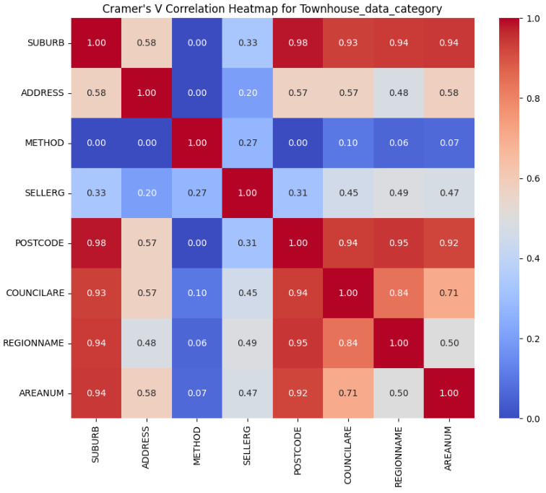

Figure 9 Correlation Heatmap for Categorical Variables for Different Types of Buildings

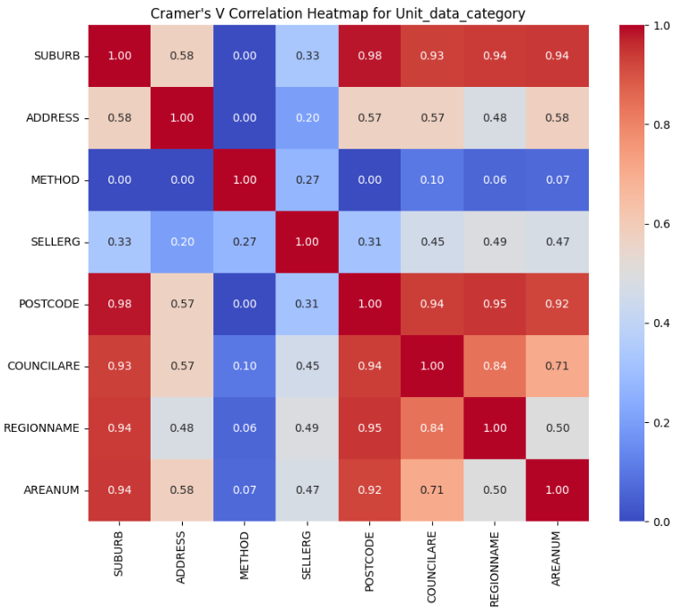

Figure 10 Correlation Heatmap for Categorical Variables for Different Types of Buildings

It can be observed that the results of the correlation analysis for categorical variables in the house dataset align with the findings in the previous analysis. Specifically, a significant correlation exceeding 95% persists between *SUBURB* and *REGIONNAME*, as well as between *COUNCILARE* and *POSTCODE*. These variables have been reduced to just *REGIONNAME* for further analysis.

Next, the correlation between numerical variables is analysed.

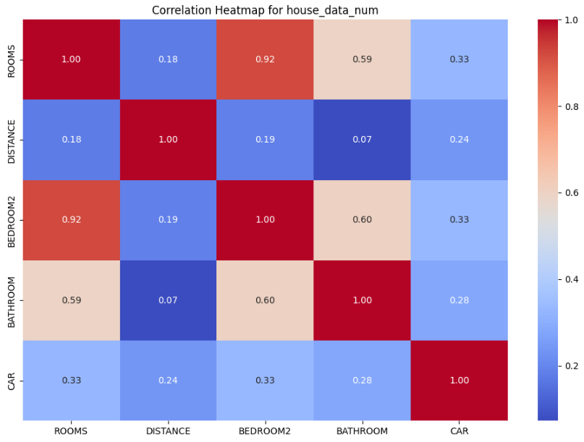

Figure 11 Correlation Heatmap for Numeric Variables for House Buildings

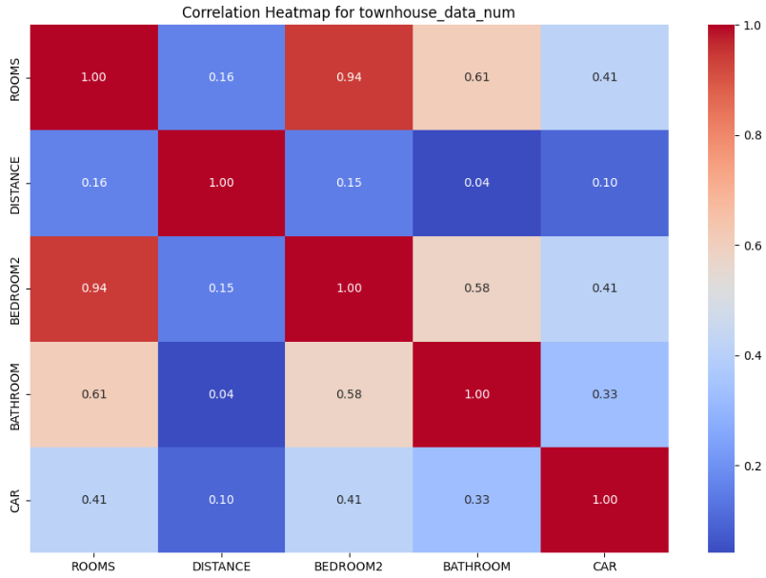

Figure 12 Correlation Heatmap for Numeric Variables for House Buildings

From Figures 11 and 12, it is evident that the numerical variables for houses and townhouses exhibit a consistent pattern of correlation. Both *BEDROOM2* and *BATHROOM* show a significant relationship with *ROOMS*, exceeding 60%.

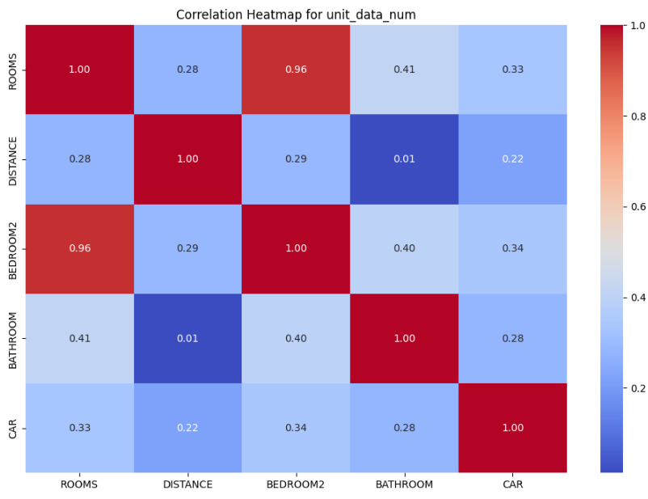

Figure 13 Correlation Heatmap for Numeric Variables for House Buildings

However, in the case of units, the correlation between *BATHROOM* and *ROOMS* is only 41%, indicating a less pronounced relationship.

Based on these correlations, it is advisable to remove the *BEDROOM2* and *BATHROOM* variables for houses and townhouses, while retaining the *BATHROOM* variable for units.

**Model Making**

After experimenting with various parameter combinations, the model that achieved the highest accuracy for house data is characterized by the following parameter settings: a regularization parameter (C) of 10, the utilization of the Radial Basis Function (RBF) kernel (commonly known as the Gaussian kernel, which is suitable for non-linear classification problems), and a gamma value of 0.01.

The performance of this model is shown in table 5:

|  |  |  |
| --- | --- | --- |
|  | Metric | Value |
| 0 | Accuracy | 0.71 |
| 1 | Precision | 0.71 |
| 2 | Recall | 0.71 |
| 3 | F1 Score | 0.60 |

Table 5 Performance Metrics of SVM model for Houses

Likewise, when it comes to the townhouse data, a range of parameter models were employed to train the SVM model. After assessing their performance, it became evident that three-parameter combinations yielded an accuracy of 79%. These parameter sets are as follows: {'C': 0.1, 'kernel': 'rbf', 'gamma': 'scale', 'random_state': 42'}, {'C': 1.0, 'kernel': 'rbf', 'gamma': 'scale', 'random_state': 42'}, and {'C': 1.0, 'kernel': 'rbf', 'gamma': 0.001, 'random_state': 42'}.

In line with the Occam's razor principle, the chosen model is selected based on its specific parameters {'C': 1.0, 'kernel': 'rbf', 'gamma': 0.001, 'random_state': 42'}. This choice is made because it features a higher 'C' value and a smaller 'gamma' value. This configuration implies a reduced penalty for misclassification and a relatively uncomplicated decision boundary, aligning with the principle of favouring simplicity in model selection. The performance of this model is shown in table 6:

|  |  |  |
| --- | --- | --- |
|  | Metric | Value |
| 0 | Accuracy | 0.82 |
| 1 | Precision | 0.73 |
| 2 | Recall | 0.82 |
| 3 | F1 Score | 0.76 |

Table 6 Performance Metrics of SVM model for townhouses

In the context of the dataset for units, various parameter combinations were explored. Among these, two specific combinations emerged, both achieving an accuracy of 0.82. These combinations are as follows: {'C': 1.0, 'kernel': 'rbf', 'gamma': 0.1, 'random_state': 42'} and {'C': 10.0, 'kernel': 'rbf', 'gamma': 0.01, 'random_state': 42'}.

Adhering to Occam's razor principle, the simpler model is selected. Simplicity often leads to improved generalization and reduced risk of overfitting the training data. Consequently, the preference is to opt for the parameter combination {'C': 1.0, 'kernel': 'rbf', 'gamma': 0.1, 'random_state': 42'}. This choice is underpinned by the fact that this model exhibits a more straightforward decision boundary, characterized by a lower 'C' value and a higher 'Gamma' value. The performance of this model is shown in table 7:

|  |  |  |
| --- | --- | --- |
|  | Metric | Value |
| 0 | Accuracy | 0.82 |
| 1 | Precision | 0.73 |
| 2 | Recall | 0.82 |
| 3 | F1 Score | 0.76 |

Table 7 Performance Metrics of SVM model for Units

**Explanation:** All constructed SVM models utilize the Radial Basis Function (RBF) as the kernel function. The RBF kernel allows SVM to perform non-linear mapping in a high-dimensional space, mapping input data to an infinite-dimensional feature space. The decision boundaries generated by the RBF kernel are typically non-linear and may exhibit highly convoluted shapes. The non-linear mapping and high-dimensional space introduce complexity to the model, making it impossible to interpret the specific roles and importance of each feature in the original input space.

### B2. ANN

The model for house data with the highest accuracy was achieved by experimenting with a range of parameter combinations and it includes three hidden layers with 64, 32, and 16 neurons, the model was trained for twenty epochs, and each epoch used a batch size of thirty-two samples.

|  |  |  |
| --- | --- | --- |
|  | Metric | Value |
| 0 | Accuracy | 0.62 |
| 1 | Precision | 0.62 |
| 2 | Recall | 0.62 |
| 3 | F1 Score | 0.62 |

Table 8 Performance Metrics of ANN model for Houses

For the townhouse ANN model, experimenting with different parameter combinations, the model achieves the highest accuracy when the first hidden layer has 128 neurons, the second hidden layer has sixty-four neurons, the number of training epochs is set to 10, and the batch size for each training step is sixty-four.

|  |  |  |
| --- | --- | --- |
|  | Metric | Value |
| 0 | Accuracy | 0.77 |
| 1 | Precision | 0.67 |
| 2 | Recall | 0.79 |
| 3 | F1 Score | 0.71 |

Table 9 Performance Metrics of ANN model of Townhouses

The model for unit data with the highest accuracy was also achieved by experimenting with a range of parameter combinations. In the end, it was found that when the ANN model has 128 neurons in the first hidden layer, sixty-four neurons in the second hidden layer, ten training epochs, and a batch size of 64, the model achieved the highest accuracy, reaching 0.76.

|  |  |  |
| --- | --- | --- |
|  | Metric | Value |
| 0 | Accuracy | 0.76 |
| 1 | Precision | 0.69 |
| 2 | Recall | 0.73 |
| 3 | F1 Score | 0.71 |

Table 10 Performance Metrics of ANN model for Units

**Explanation:** The accuracy as a metric for appraising model efficacy and, optimal architectural configurations for residential structures, including houses, townhouses, and units, reveals a preference for a two-tiered hidden layer arrangement. Specifically, the preeminent artificial neural network (ANN) model for houses manifests with a primary hidden layer featuring 128 neurons, succeeded by a secondary layer housing sixty-four neurons. Notably, the distinguishing factor lies in the parameterization of these models. The paramount ANN model for houses culminates with 172,388 parameters, while its townhouse counterpart exhibits a more parsimonious parameter count of 115,652. The ANN model tailored for units occupies an intermediary position, featuring 124,228 parameters. All three models employ the SoftMax function, wherein SoftMax, situated as the terminal layer within the neural network architecture, prognosticates the likelihood of each categorical outcome.

### B3. KNN

In this session, the **K-Nearest Neighbours (KNN)** algorithm is implemented using the Melbourne housing dataset. The primary goal is to create a predictive model that can assist in making accurate price predictions for several types of properties. As mentioned before, one crucial step in the data preparation process is **feature selection.** By carefully choosing the relevant features such as square footage, number of bedrooms, location, and other property characteristics, the effectiveness of the KNN model can be improved.

Furthermore, the dataset has been strategically divided into three distinct subsets based on the property types: **house, unit, and townhouse.** This segmentation allows to tailor the KNN model to the unique characteristics of each property category. By training separate KNN models for each category, Specific factors and dependencies that influence property prices within each type can be accounted for. This structured approach enhances the ability to create accurate predictions tailored to the different property types in the Melbourne housing market. The Minkowski distance is used for all the categories, but the count of neighbours is different.

**Houses**: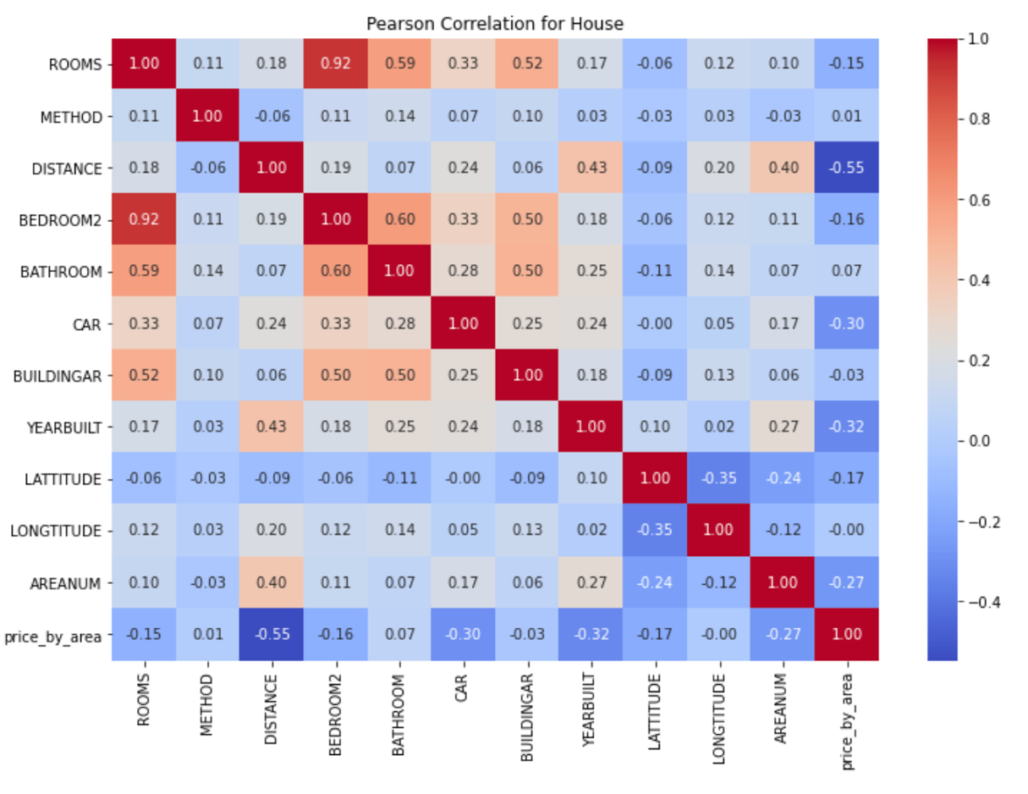

Figure 14 Correlation Matrix for Houses

Figure 14 shows the Pearson correlation coefficients between all pairs of variables in the house dataset and displays the correlation matrix with the specified title. Pearson correlation measures the linear relationship between variables and can help you understand how variables in the dataset are related to each other.

A strong correlation analysis reveals a significant relationship between *ROOMS* and other variables such as BEDROOM2, BATHROOM, and *BUILDINGAR* in the dataset. To simplify the model and maintain accuracy, *ROOMS* is retainedas the representative variable, given its high correlation with these other features. This choice streamlines the analysis and ensures that the most critical information for the predictive model is captured, reducing redundancy and multicollinearity.

|  |  |
| --- | --- |
|  | log_price_level |
| LONGTITUDE | 0.118628 |
| CAR | 0.091053 |
| YEARBUILT | 0.059472 |
| ROOMS | 0.055863 |
| AREANUM | 0.0497 |
| LATTITUDE | 0.032392 |
| METHOD | 0.018726 |
| DISTANCE | 0.000047 |

Table 11 Information gain between log_price_level with input features for type House

According to the information gained between input features and with target feature, the *LONGTITUDE* has the highest correlation with *log_price_level* which means the feature has the highest influence on *log_price_level.* The number 5 of neighbours is selected as the final parameter.

**Townhouses:**

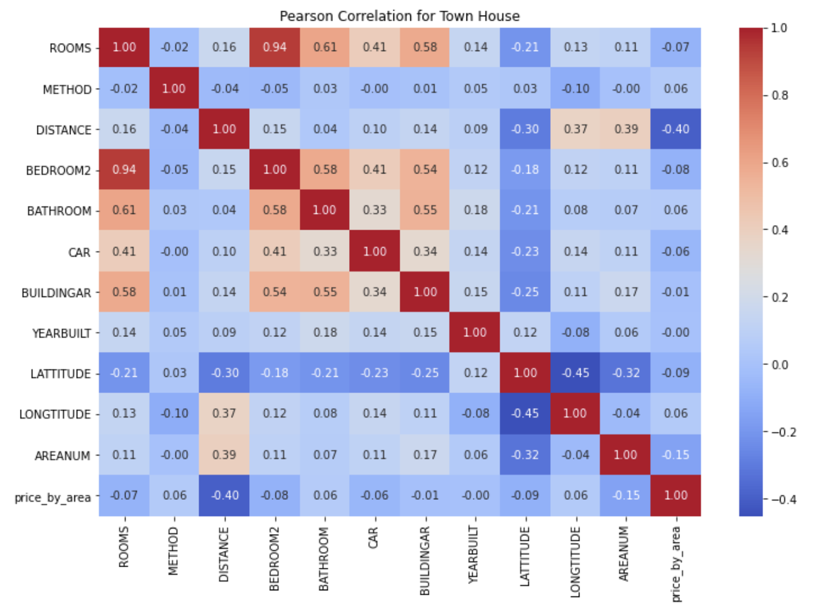

Figure 15 Correlation Matrix for Townhouses

From Figure 15, it becomes apparent that *ROOMS* demonstrate a notably high correlation with *BEDROOM2*, *BATHROOM*, and *BUILDINGAR*. Consequently, *ROOMS* is retained as a key variable in the analysis. This decision is driven by the strong correlations observed, indicating that *ROOMS* holds valuable predictive power for understanding and forecasting house prices.

|  |  |
| --- | --- |
|  | log_price_level |
| DISTANCE | 0.18132 |
| AREANUM | 0.113813 |
| METHOD | 0.074855 |
| LONGTITUDE | 0.07257 |
| YEARBUILT | 0.036767 |
| CAR | 0.018163 |
| LATTITUDE | 0.01774 |
| ROOMS | 0.01202 |

Table 12 Information gain between log_price_level with input features for type townhouse.

According to the information gained between input features and with target feature, the *DISTANCE* has the highest correlation with *log_price_level* which means the feature has a higher influence on *log_price_level.* The number 1 of neighbours is selected as the final parameter.

**Units:**

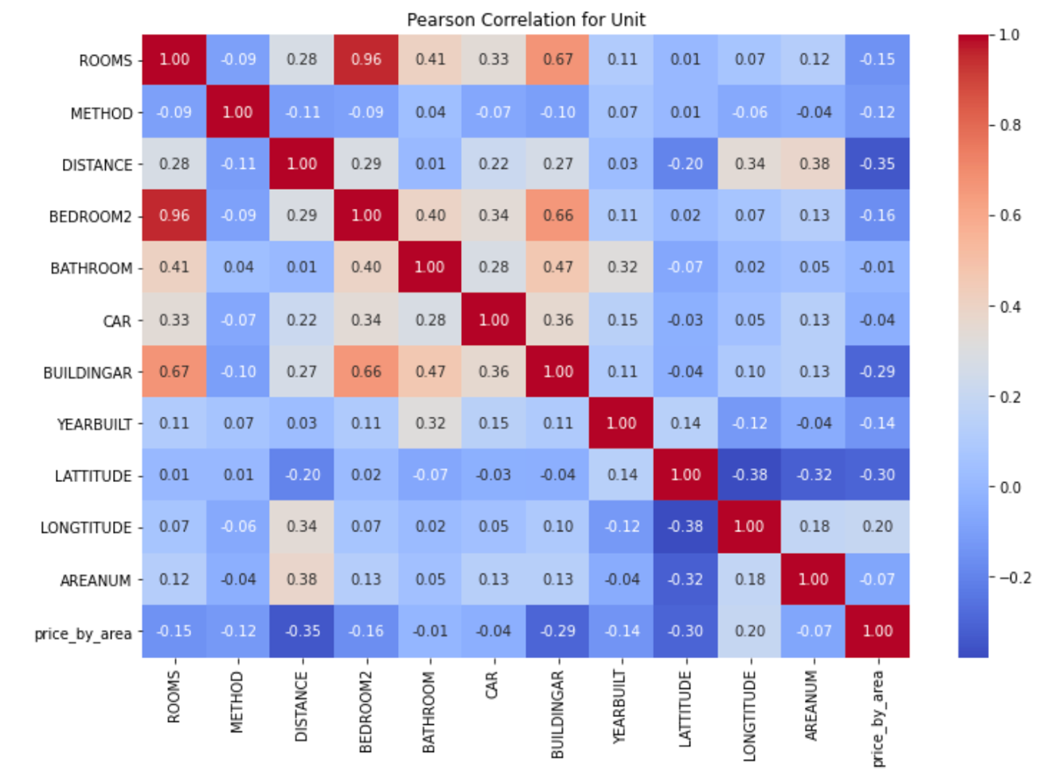

Figure 16 Correlation Matrix for Units

From Figure 16, it is evident that *ROOMS* exhibit a remarkably strong correlation with *BEDROOM2* and *BUILDINGAR*. Recognizing the significance of these relationships, *ROOMS* is retained as a key variable for the analysis. This choice simplifies the model and focuses attention on *ROOMS*, a variable that effectively captures crucial information for predicting house prices.

|  |  |
| --- | --- |
|  | log_price_level |
| DISTANCE | 0.202743 |
| LATTITUDE | 0.155074 |
| LONGTITUDE | 0.13279 |
| ROOMS | 0.098943 |
| AREANUM | 0.095834 |
| CAR | 0.086665 |
| BATHROOM | 0.04062 |
| YEARBUILT | 0.03276 |
| METHOD | 0.019728 |

Table 13 Information gain between log_price_level with input features for type Unit

According to the information gained between input features and with target feature (shown in Table 13), the *DISTANCE* has the highest correlation with *log_price_level* which means the feature has a higher influence on *log_price_level.* The number 5 of neighbours is selected as the final parameter.

### B4 Decision Tree

The following graphs will show the decision tree, for better visualization only shows the first three depth nodes. The datasets have three classes, orange stands for the lower price, the green colour represents the middle price, and the purple colour means the higher price. The bright represents the rate of different classes. There are four lines in each node, the first line means the split rule on this node, the second line is the performance of the split rule on this node, the third line shows the sample count, and the last line is the count for each class.

**Houses:**

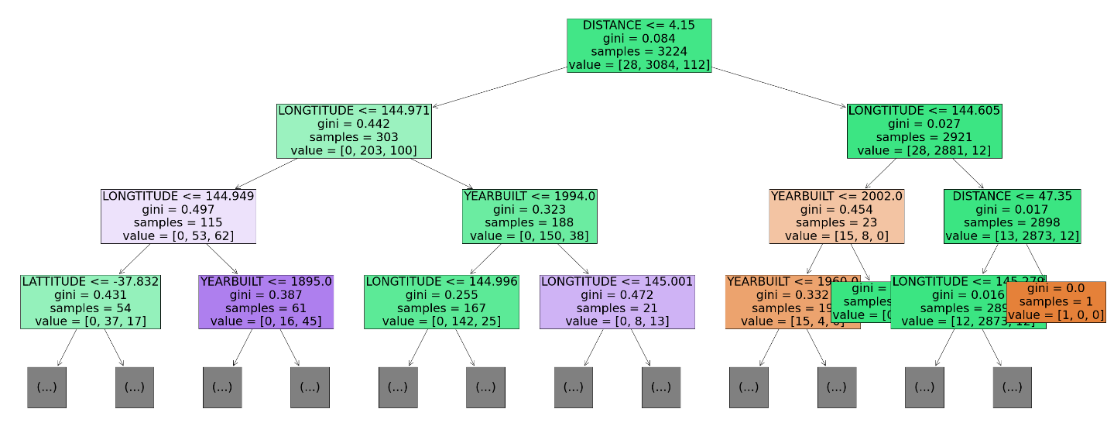

Figure 17 Tree for type House

Figure 17 shows the split tree for the house dataset. The first node using the feature *DISTANCE* to split, all the *DISTANCE* less or equal 4.15 will exist on the left side, otherwise on the right side, repeat the splitting on all the new nodes, until it cannot split anymore, such as only one class exists on the node or there are no more features can separate the classes.

|  |  |
| --- | --- |
| Importance | features |
| 0.363401 | LONGTITUDE |
| 0.245489 | DISTANCE |
| 0.181163 | LATTITUDE |
| 0.136212 | YEARBUILT |
| 0.033565 | ROOMS |
| 0.029342 | METHOD |
| 0.010549 | CAR |
| 0.000279 | AREANUM |

Table 14 Importance between input features with log_price_level for type house

From the importance level in Table 14, the influence of different input features on the target feature can be easily seen. For this case, the *LONGTITUDE* has the highest influence on *log_price_level.*

**Townhouses:**

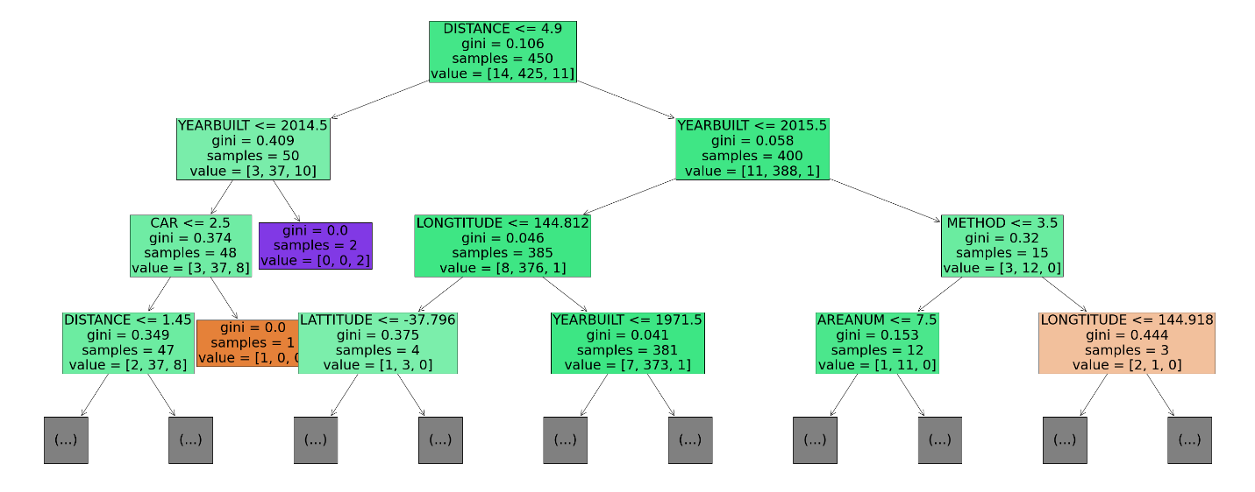

Figure 18 Tree for type Townhouse

Figure 18 shows the split tree for the house dataset. The first node using the feature *DISTANCE* to split, all the *DISTANCE* less or equal 4.9 will exist on the left side, otherwise on the right side, repeat the splitting on all the new nodes, until it cannot split anymore, such as only one class exists on the node or there are no more features can separate the classes.

|  |  |
| --- | --- |
| importance | features |
| 0.242003 | DISTANCE |
| 0.235373 | LONGTITUDE |
| 0.139192 | YEARBUILT |
| 0.123724 | AREANUM |
| 0.118744 | LATTITUDE |
| 0.076497 | METHOD |
| 0.064466 | CAR |
| 0 | ROOMS |

Table 15 Importance between input features with log_price_level for type townhouse

From the importance level in Table 15, the influence of different input features on the target feature can be easily seen. For this case, the *DISTANCE* has the highest influence on *log_price_level.*

**Units:**

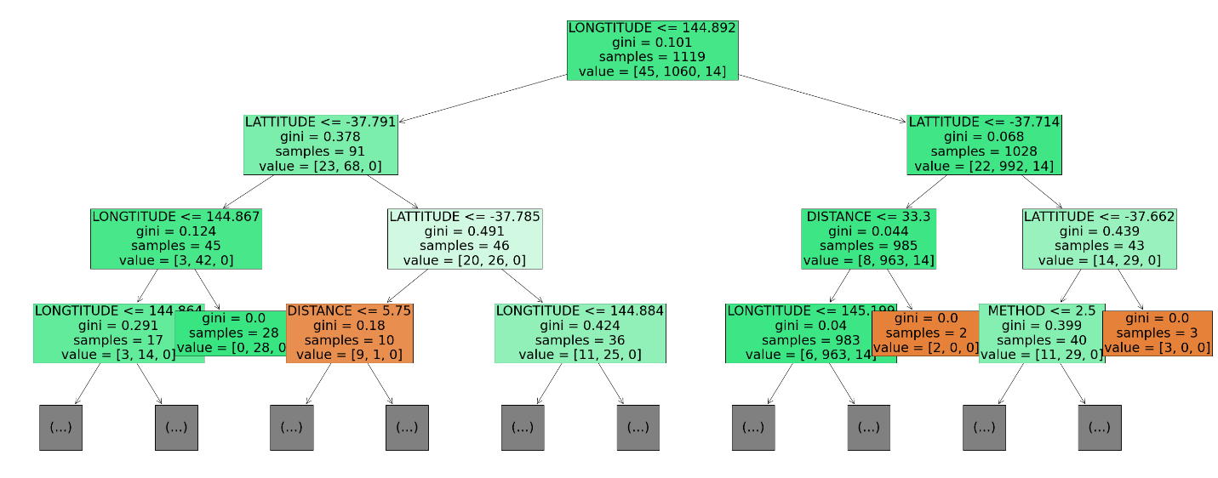

Figure 19 Tree for type Unit

Figure 19 presents the split tree for the house dataset. The initial node utilizes the feature *LONGTITUDE* for segmentation, designating all data points with a DISTANCE of 144.892 or less to the left side, and those exceeding this value to the right. This process of bifurcation is replicated on all subsequent nodes until further division is infeasible, typically when a node contains a singular class or lacks additional features to differentiate between classes.

|  |  |
| --- | --- |
| importance | features |
| 0.35693 | LATTITUDE |
| 0.318772 | LONGTITUDE |
| 0.082574 | DISTANCE |
| 0.074197 | YEARBUILT |
| 0.060592 | METHOD |
| 0.050928 | ROOMS |
| 0.040236 | CAR |
| 0.015771 | AREANUM |
| 0 | BATHROOM |

Table 16 Importance between input features with log_price_level for type unit

From the importance level in Table 16, the influence of different input features on the target feature can be easily seen. In this case, the *LATTITUDE* has the highest influence on *log_price_level.*

### Accuracy Comparison

|  |  |  |
| --- | --- | --- |
| Model | Name | Accuracy |
| Decision | House | 94. 80% |
| Decision | Townhouse | 90. 27% |
| Decision | Unit | 93. 21% |
| KNN | House | 94. 92% |
| KNN | Townhouse | 88. 49% |
| KNN | Unit | 94. 29% |

Table 17 Summary statistics for Decision Tree and KNN

Three different classification models (Decision Tree and K-Nearest Neighbours) are created and evaluated for three subsets of housing data**: House Data, Unit Data, and Townhouse Data.**

Table 17 shows test accuracy results demonstrating the performance of both Decision Tree and KNN classification models applied to different subsets of housing data. According to the result based on Figure 22, the KNN has a better performance than the decision tree. Notably, the accuracy of KNN on the **House Data** subset exhibits the highest accuracy, reaching an impressive accuracy score of 94.92%. In comparison, the **Townhouse Data and Unit Data** subsets also perform well, achieving test accuracy scores of 88.49% and 94.29%, respectively. These results underscore the effectiveness of the models in making accurate predictions and classifications regarding various housing data.

## C. Time series

Time series analysis in the Melbourne real estate housing market is used to analyse and predict trends in housing prices over time. It helps identify patterns, such as long-term trends, seasonal fluctuations, and cyclical movements in the market. Using statistical and machine learning models like ARIMA, are useful to uncover insights and forecast future housing prices.

By dividing the dataset into two subsets based on **land size for houses and townhouses** and **building area for units**, to achieve the primary objective of analysing and predicting the price more accurately. Price by building area and price by land size are the newly calculated variables for analysis. Time Series models mainly focus on two variables.

1. Target Variable (e.g., **Price**): This is the main variable of interest that the model tries to forecast. In the context of Melbourne real estate, this is typically the housing price.
2. Time (e.g., **Date**): The time variable represents the specific intervals at which the data is collected. It is crucial as it provides the temporal dimension to the data. In a timeseries model like ARIMA, the date or time is not used as a typical explanatory variable. Instead, it is inherent in the structure of the model, as ARIMA analyses the way values change over time.

In the data pre-processing part, aggregating the data weekly, and obtaining the weekly average prices so as a result the two newly calculated columns *Week* and *Price* are used for both the subsetsbased on land size for houses and townhouses and building area for units. Upon initial examination, the *Price* column has missing values for both datasets, and these were imputed using the mean of the available prices.

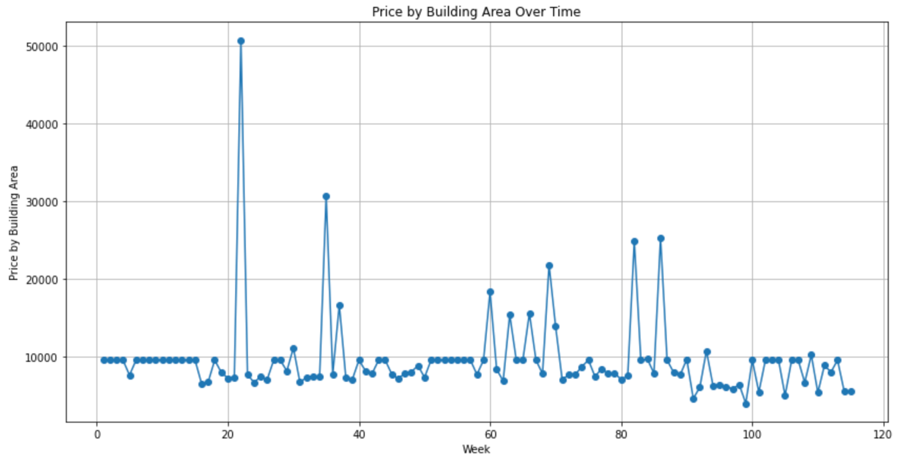

Figure 20 Trend of Price by Building Area over the time

The dataset for units (Price by Building Area) shows stationarity from week one to week fifteen as can be seen in figure 20, showing no major trends and fluctuations. So, starting the series from week sixteen for further analysis and predictions.

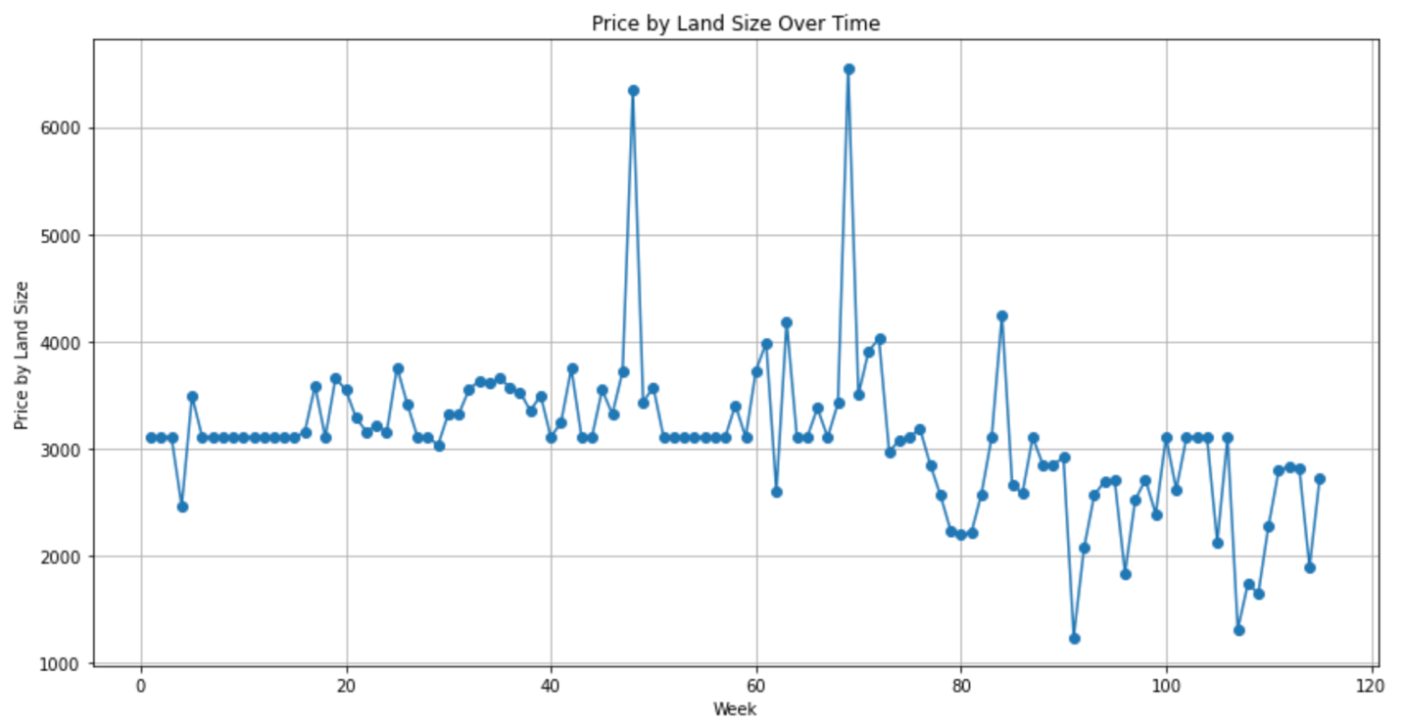

Figure 21 Trend of Price by Land Size over time

Similarly in Figure 21, from a dataset of houses and townhouses (Price by Land Size), half of the series is stationary as there is not much change in pattern over the period from week one to week fifty-eight. Only the data starting from week fifty-nine is used in further observations and model predictions.

To stabilize the variance and make the data more suitable for modelling, apply a logarithmic transformation to the *Price* column and create a new series called *Log_Price* for both datasets.

Using the Autocorrelation Function (ACF) and Partial Autocorrelation Function (PACF) plots of the log-transformed price and checking for the **Akaike information criterion (AIC)** value which is a widely used measure in statistical model selection, particularly in the context of time series analysis with models like ARIMA (Autoregressive Integrated Moving Average). The purposes of AIC are:

1. Model Selection: The AIC helps in choosing between multiple competing models. A lower AIC value indicates a better model. It balances model fit (how well the model explains the data) with model complexity (the number of parameters).
2. Penalizing Complexity: The AIC penalizes models with more parameters to prevent overfitting. This ensures that the selected model is not just fitting the noise in the data.

Also, in different models and checking the residuals for white noise, it is identified that the **ARIMA (0,1,1)** model is a potential candidate in both cases. This model was chosen based on the following observations:

1. The series required one order of differencing to make it stationary (d=1), hence the '1' in the middle of the ARIMA order.
2. The PACF had a significant spike at lag one, suggesting a q component as 1.

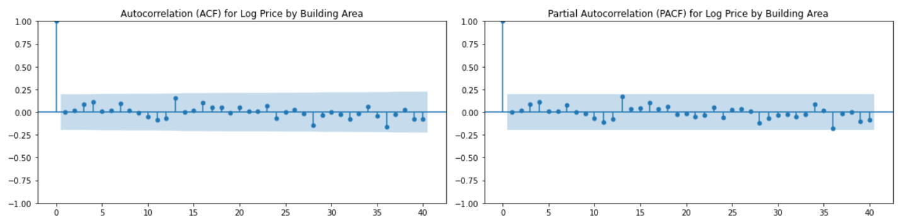

Figure 22 ACF and PACF for Log Price by Building Area

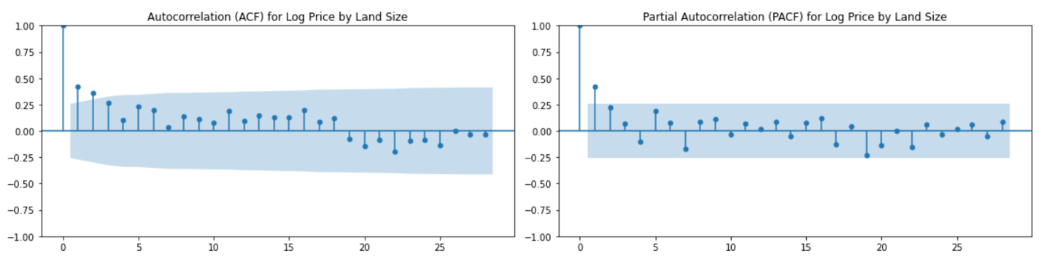

Figure 23 ACF and PACF for Log Price by Land Size

AIC ((Akaike Information Criterion): = 95.288

|  |  |  |  |  |
| --- | --- | --- | --- | --- |
| coef | value | Std err | z | P>|z| |
| ma.L1 | -0.9390 | 0.047 | -19.800 | 0.000 |
| sigma | 0.1441 | 0.011 | 13.030 | 0.000 |

Table 18 Model statistics for Log Price by Building Area

AIC ((Akaike Information Criterion): = 5.906

|  |  |  |  |  |
| --- | --- | --- | --- | --- |
| coef | value | Std err | z | P>|z| |
| ma.L1 | -0.7821 | 0.112 | -6.987 | 0.000 |
| sigma | 0.595 | 0.008 | 7.858 | 0.000 |

Table 19 Model Statistics Log Price by Land Size

A low p-value of coefficients (typically ≤ 0.05) from Tables 18 and 19, indicates strong evidence against the null hypothesis, so reject the null hypothesis for both scenarios. Lower AIC values indicate a more appropriate model choice, given the balance between the goodness fitting fit the data (likelihood) well and keeping the model as simple as possible.

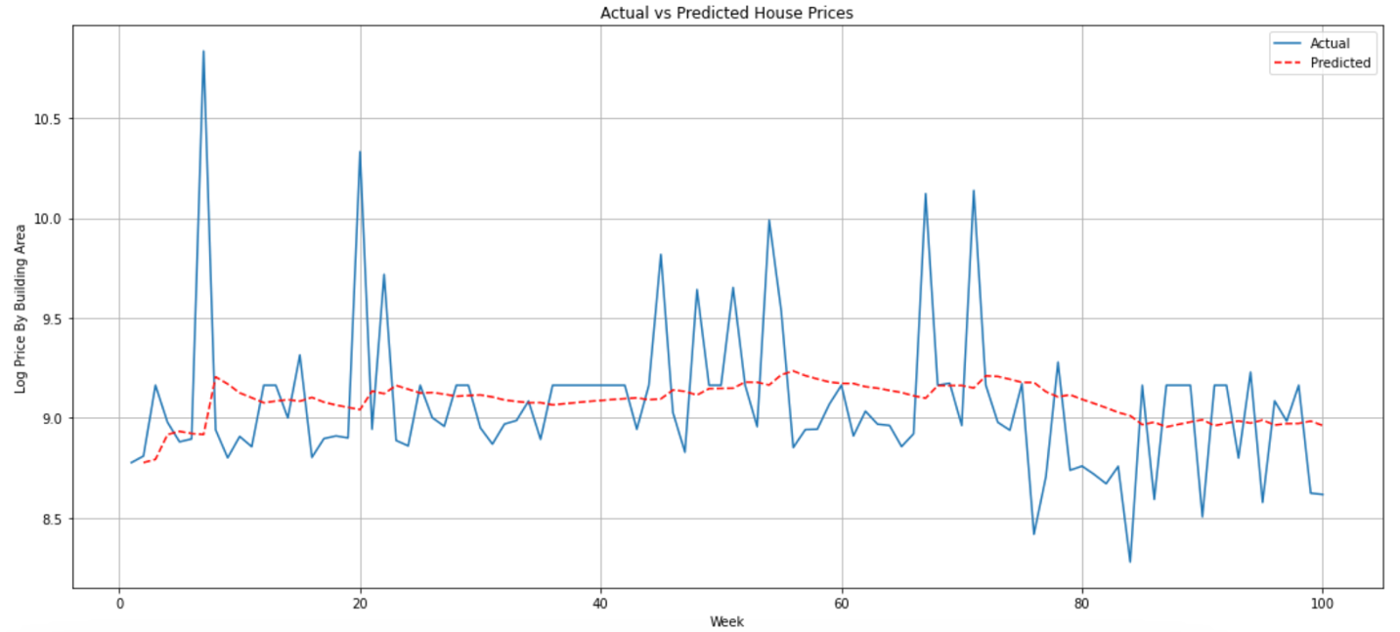

Figure 24 Actual vs Predicted House Prices for model Log Price by Building Area

The Model equation for ARIMA (0,1,1) model for Log Price by Building Area using the backward shift operator (B) with the value of 0.385 for standard error of residuals and the estimated coefficient is:

**(1−B) Yt = (1 - 0.9390B) εt​**

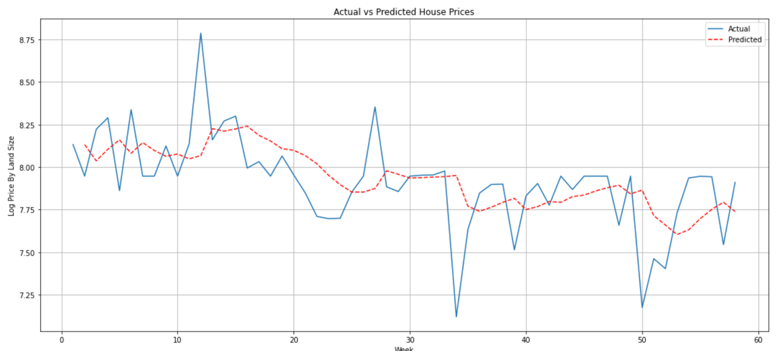

Figure 25 Actual vs Predicted House Prices for model Log Price by Land Size

The Model equation for ARIMA (0,1,1) model for Log Price by Land Size having a standard error of residuals 1.276, using the backward shift operator (B) and the estimated coefficient, is:

**(1−B) Yt = (1 - 0.7821B) εt​**

where:

(Yt​) represents the log-transformed price at time ‘t’.

(εt​) is the white noise error term at time ‘t’.

The model equation for ARIMA, when expressed using the backshift (B) operator, succinctly captures the relationship between current and past values in a time series. This equation helps in modelling a time series by capturing its dependency on past values and past errors.

|  |  |
| --- | --- |
| For model Log Price by Building Area | |
| MAE (Mean Absolute Error) | 0,.346 |
| RSME (Root Mean Squared Error) | 0.958 |
| MAPE (Mean Absolute Percentage Error) | 3.816 |

Table 20 Performance indicators for model Log Price by Building Area

Table 20 illustrates that the model exhibits relatively small forecast errors, with an average deviation of 0.346 units from actual values (MAE), a larger penalty for occasional big errors indicated by an RMSE of 0.958, and an average percentage error of 3.816% (MAPE), suggesting a generally accurate model.

|  |  |
| --- | --- |
| For model Log Price by Land Size | |
| MAE (Mean Absolute Error) | 0,.319 |
| RSME (Root Mean Squared Error) | 1.095 |
| MAPE (Mean Absolute Percentage Error) | 4.045 |

Table 21 Performance indicators for model Log Price by Land Size

The performance metrics indicate that the forecasting model has an average absolute error of 0.319 units (MAE), which reflects moderate accuracy. The RMSE is 1.095, showing that when giving more weight to larger errors, the average error is slightly higher. The MAPE of 4.045% suggests that the model's predictions are off by just over 4% on average, which might be accepted.

From the above results the models used to predict housing prices in Melbourne are doing a fairly good job. For the model, which is the price based on the building area for units, the predictions are usually only off by a small amount - on average, less than 3.8% different from the actual prices. The second model, focusing on houses and townhouses based on land size, is also quite accurate. It is typically only about 4% off from the real prices. Both models are a bit more off when there are bigger differences between the predicted and actual prices, but overall, they are reliable for getting a general idea of where housing prices might go. This is helpful for people interested in the real estate market, but it is important to remember that these are just estimates and actual prices can vary due to many factors.

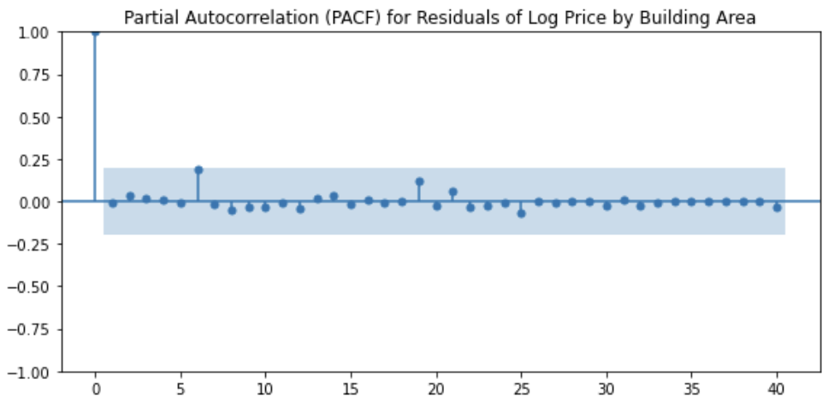

Figure 26 PACF of the residuals of model Log Price by Building Area

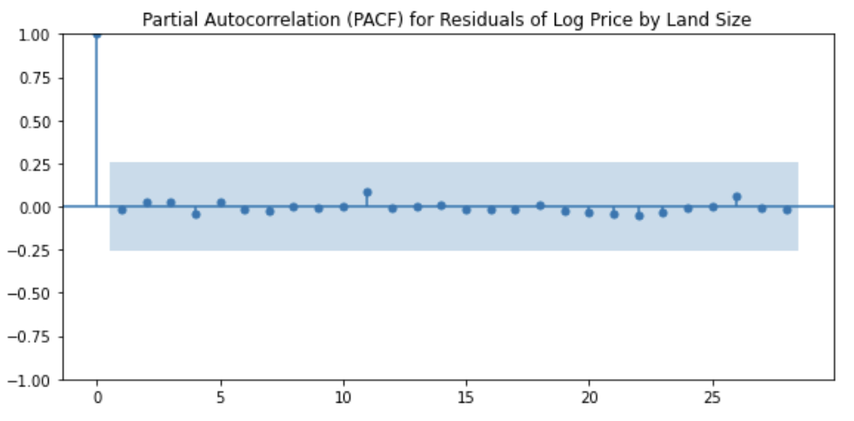

Figure 27 PACF of the residuals of model Log Price by Land Size

The Partial Autocorrelation Function (PACF) plot in Figures 26 and 27, of the residuals of the fitted ARIMA (0,1,1) models for both datasets shows that most of the partial autocorrelations are within the confidence interval (the blue shaded area), which suggests that there is no significant autocorrelation at those lags. This is an indication that the model has captured the underlying process well, and the residuals are behaving like white noise, which is what the aim is in a well-specified model.

The significance of having residuals that are white noise in such models cannot be overstated. Residuals, the differences between observed values and model predictions, being white noise imply that they are random, independent, and have a constant mean and variance. This characteristic is crucial because it signifies that the model has successfully extracted all the available information and patterns from the data, leaving behind only the randomness inherent in any real-world data. It means the model is not systematically biased and has accounted for all autocorrelations, trends, and cyclic patterns in the data. Essentially, white noise residuals are a key indicator of a well-fitted model, ensuring that the model's predictions and inferences are reliable and that it has captured the true underlying process generating the time series. This combination of favourable AIC and white noise residuals is often the hallmark of a robust and effective time series model, leading to more accurate and trustworthy forecasts and insights. So, the ARIMA (0,1,1) model can be used for future price prediction according to the trend.

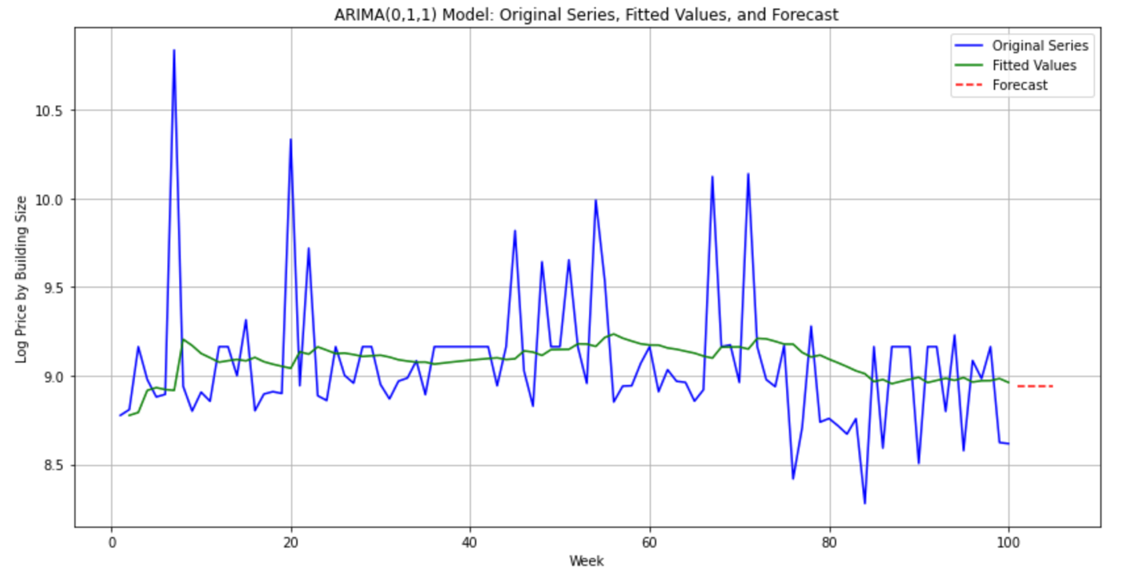

Figure 28 Future Predictions of Log Price by Building Size

Forecasting the next five periods for the model based on building size (units) gives a straight unchanging pattern shown with a dashed red line in Figure 28, which is based on the first forecasted value (7633.2260) which is less than the average.

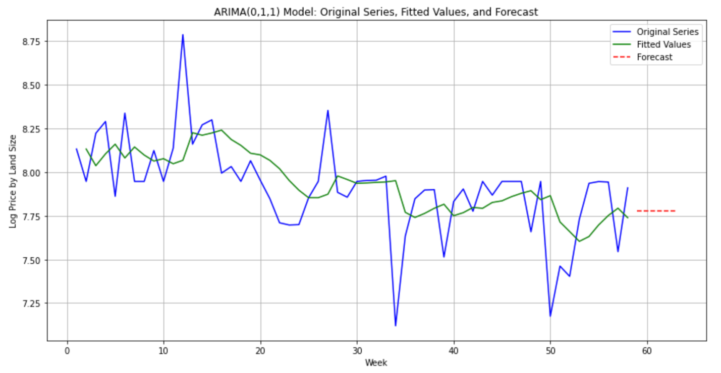

Figure 29 Future Predictions of Log Price by Land Size

Forecasting the next five periods for the model based on building size (units) gives a straight unchanging pattern that can be observed in Figure 29, which is based on the first forecasted value (7633.2260) which is less than the average. This is based on the first forecasted value which is 2383.6370 which is also less than the average.

Time series analysis of Melbourne housing pricing using the ARIMA (0,1,1) models, developed for two different segments (based on land size for houses and townhouses, and based on building area for units), have shown good results in predicting short-term price movements. However, continuous monitoring and updating of the model with new data and factors are recommended to maintain its relevance and accuracy in a dynamically changing market environment. Also made sure that the predictions were dependable by checking if the patterns found in the past data were consistent with what is expected. The predictions suggest a stable trend in prices for the near future, but it is important to remember that these are based on past trends and actual future prices could be influenced by many other factors like economic conditions or new policies. This study provides a useful tool for those interested in the real estate market, but it should be used with an understanding of its limitations and the ever-changing nature of real estate markets.

## D. Bayesian Network

**A Bayesian network** is a tool for unveiling relationships among variables, making it particularly adept at exploring the dynamics within a system. In this analysis, the focus centres on examining the inherent connections between the target variable, PRICE, and all sets of variables. By leveraging the Bayesian network framework, the aim is to discern the potential relationships between **PRICE** and other relevant factors. This method allows to capture of the interdependencies and uncertainties present in the dataset, providing an understanding of how each variable may influence the target variable**, PRICE**. Through this exploration, insights are gained into the complex web of relationships that contribute to the overall dynamics of the system, enhancing the ability to make informed decisions or predictions in scenarios where uncertainty prevails.

The estimation of the **Bayesian network's structure** stands as a foundational and critical phase in the modelling procedure. This step assumes a pivotal role in delineating the complex web of relationships existing among variables within the network. Through structure estimation, insights are gleaned regarding the direct connections between variables, thereby unveiling the network of dependencies. Concurrently, it allows the discernment of variables that exhibit conditional independence, shedding light on segments of the system where variables operate autonomously. Furthermore, the direction of influence between variables is explicated, providing an understanding of the **cause-and-effect relationships** inherent in the data., the process of structure estimation **emerges as a pivotal endeavour,** unlocking the full potential of Bayesian networks for tasks related to modelling and prediction.

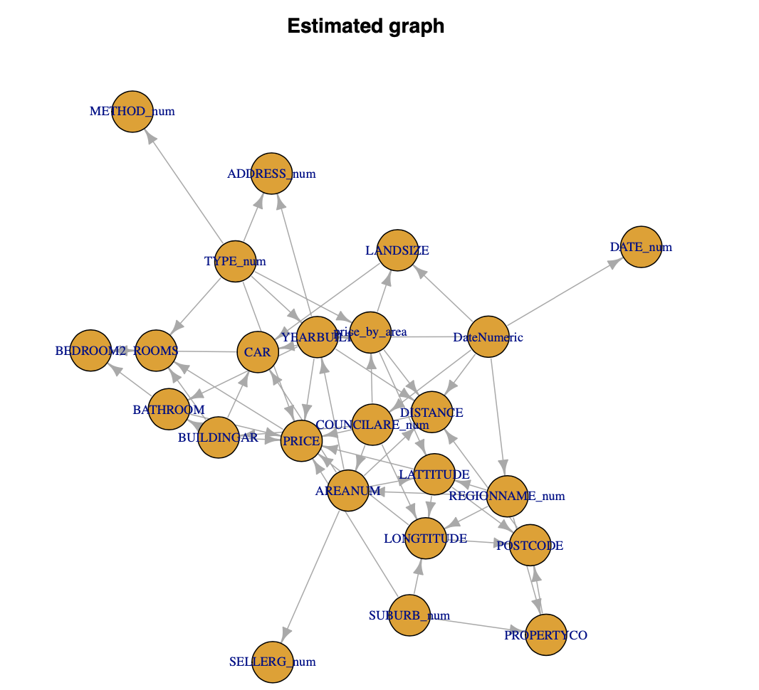

Figure 30 PDAG of all variables

A **PDAG** stands for "**Partially Directed Acyclic Graph"** in the context of Bayesian networks. Bayesian networks offer a more relaxed representation of the relationships between variables, acknowledging uncertainties in the orientation of edges and providing a framework for capturing the underlying dependencies in a probabilistic and flexible manner.

In this section, exploration into the concepts of **causality and Markov blanket** is done to explore how they contribute to understanding the relationships within Bayesian networks.

**Causality** is a fundamental guiding principle when constructing Bayesian networks, providing invaluable assistance in unravelling the relationships among variables. In the context of these graphical models, which aim to capture **both probabilistic dependencies and cause-and-effect connections**, understanding the direction of influence is paramount. Causal knowledge not only informs **the construction** of the Bayesian network structure, where directed edges signify the **causal relationships** between variables, but it also enhances model interpretability. The resulting transparency allows users to discern which variables influence others and the way this influence unfolds.

The **causality values** derived in the provided R code originate from the **IDA (Invariant Causal Prediction) algorithm**. IDA (Hindmarsh, 2000) is a powerful causal discovery method used to discern causal relationships within observational data. It estimates the influence or impact of various variables on a specific target variable by considering the statistical relationships and dependencies present in the dataset.

Within the R code, the algorithm operates through a systematic process. It initializes a data frame to gather the calculated causal effects and sets a regularization parameter to adjust the covariance matrix, mitigating potential overfitting. Then, it iterates through each variable, except for the target variable (*PRICE*), estimating their individual causal effects on *PRICE*. The Interventional Distribution Algorithm (IDA) (Hindmarsh, 2000) facilitates the estimation of a causal effect within a causal model, focusing on the target variable *PRICE* while acknowledging observed evidence variables (Every variable). This process is initiated by setting *PRICE* as the target variable and identifying every variable as the observed evidence. The algorithm (Hindmarsh, 2000) then proceeds by initializing the estimated interventional distribution for *PRICE* through the application of an intervention to a variable, denoted as Y, indicating a specific intervention value. Subsequently, the algorithm propagates this intervention throughout the causal model, adjusting the distribution of *PRICE* based on alterations in its parent variables' values using conditional probability rules. Further refinement occurs by integrating observed evidence (every variable) through conditional probability calculations, enhancing the estimation of *PRICE*. Iteratively, the algorithm repeats this process for other variables in the model, deriving their interventional distributions under the same conditions. The result is an estimated interventional distribution of *PRICE* considering the specified intervention on Y and incorporating observed evidence variables (every variable), elucidating the causal impact of the intervention on *PRICE* within the causal model's framework.

Subsequently, the algorithm stores the absolute values of these estimated causal effects in a data frame, arranging them in order of their impact on the target variable. This process aids in comprehending the relative influence each variable possesses concerning property prices, assisting in understanding the most significant factors affecting price variations in the dataset.

The **Markov blanket** (Haggstrom, 2018) of a node in a Bayesian network is a concept crucial to probabilistic modelling, representing the minimal set of nodes that, when observed, renders the node conditionally independent of all other nodes in the network. The significance of the Markov blanket lies in its ability to encapsulate all direct influences on the node, encapsulating the information necessary for predicting its probability distribution.

In Bayesian networks, understanding the **Markov blanket** serves multiple purposes. Firstly, it (Haggstrom, 2018) facilitates efficient probabilistic inference by **isolating the relevant variables,** reducing computational complexity. This feature is particularly valuable when dealing with large and complex networks. Secondly, the Markov blanket aids in **feature selection** for predictive modelling, guiding the identification of variables that directly impact the target variable. This not only simplifies the model but also enhances its interpretability. Moreover, the Markov blanket provides insights into the immediate dependencies of a node, assisting in the **identification of influential factors** and contributing to informed decision-making (Haggstrom, 2018). In summary, the Markov blanket plays a foundational role in Bayesian networks, offering a concise representation of direct dependencies and significantly contributing to the efficiency, interpretability, and accuracy of probabilistic modelling within complex systems.

While there may be some overlap between variables involved in causality and those in the Markov blanket, they serve distinct purposes in the modelling process. The **Markov blanket** is about conditional independence and probabilistic relationships, whereas **causality** is concerned with understanding the cause-and-effect structure of the system.

In the last step, the use of the **PC (Peter and Clark) algorithm** (Tsagris, 2019), in conjunction with the identification of **Markov blankets**, is instrumental in the process of constructing Bayesian network graphs from observational data. The PC algorithm (Tsagris, 2019) employs a combination of statistical independence tests and graph search to efficiently explore **potential relationships** among variables. Its application is particularly advantageous when dealing with datasets of substantial size and complexity. The algorithm begins by establishing a skeleton graph, representing undirected edges between variables based on conditional independence tests. The integration of **Markov blanket** information is key at this stage, as it aids in narrowing down the search for dependencies by identifying the immediate influences on each node. The **Markov blanket,** encompassing a node's parents, children, and other parents of its children, contributes to the orientation of edges, transforming the skeleton graph into a **directed acyclic graph (DAG)** that encapsulates causal relationships (Tsagris, 2019). The resulting Bayesian network graph, constructed through the PC algorithm and Markov blankets, offers a clear and interpretable representation of conditional independence and causation among variables, facilitating insightful analyses and decision-making in diverse domains.

In summary, the PC algorithm is a tool for learning the structure of Bayesian networks, the inclusion of **causality and Markov blanket** information serves to refine and validate the learned structure. It enhances the accuracy of edge orientations in the **DAG,** contributes to model interpretability, and ensures that the resulting Bayesian network aligns with the underlying causal relationships within the system.

|  |  |
| --- | --- |
| variable | causality |
| ROOMS | 337614.2045 |
| REGIONNAME_num | 76681.2484 |
| BEDR00M2 | 37224.53502 |
| CAR | 35460.37397 |
| METHOD_num | 27584.56316 |
| COUNClLARE_num | 4664.226803 |
| POSTCODE | 1766.568734 |
| DATE_num | 1608.154625 |
| AREANUM | 557.414957 |
| SELLERG_num | 134.446794 |
| DateNumeric | 134.352915 |
| LANDSIZE | 36.615929 |
| ADDRESS_num | 34.083266 |
| price_by_area | 14.918559 |
| PROPERTYCO | 8.776953 |
| DISTANCE | 0 |
| BATHROOM | 0 |
| BUILDINGAR | 0 |
| YEARBUILT | 0 |
| LATTITUDE | 0 |
| LONGTITUDE | 0 |
| SUBURB_num | 0 |

Table 22 Causality of all variables

Table 22 shows causal effect estimation for each variable concerning the *PRICE* variable and subsequently ranks these variables based on the strength of their causal effects. Causal variables and their estimated effects on property prices have been ranked. *ROOMS* stands out as the most influential variable, boasting a substantial effect with a value of 337,614.20, suggesting that the number of rooms significantly influences prices. Larger values indicate a more influential effect. Following closely, *BEDROOM2* and *CAR* exhibit notable causal effects of 37,224.54 and 33,548.25, respectively. Similarly impactful, *REGIONNAME*_*num* and *METHOD*_*num* significantly affect prices with values of 30,558.44 and 27,584.56, respectively. The *COUNCILARE*_*num* variable demonstrates a substantial effect with 4,664.23, while *AREANUM*, *POSTCODE*, and *DATE*_*num* play moderately influential roles with effects of 2,568.93, 1,766.57, and 1,608.15, respectively. Conversely, *SELLERG*_num and Datenumeric display the least effect, with values around 134.45. These findings provide insights into the factors influencing property prices within the dataset.

**Bayesian Network Modelling (Three datasets)**

As mentioned before, where the TYPE variable encompasses three distinct categories – townhouse, unit, and house, a meticulous approach is paramount. Notably, when dealing with units or apartments, it is reasonable to assume a lack of individual building area data, given their shared structures. To accommodate this variation, the dataset is intelligently partitioned into three subsets corresponding to the *TYPE* category. This results in specialized subsets denoted as *num_h*, *num_u*, and *num_t*, dedicated to exploring the unique characteristics within the house, unit, and townhouse categories.

By segmenting the dataset into these three distinct subsets based on property categories, namely **house, unit, and townhouse**, the analysis is tailored to the unique characteristics and complexities of each property type. This tailored approach helps to perform a more focused examination of the factors and dependencies that influence properties within each category.

Causality information can indeed serve as a reference or guide when interpreting the structure of a Bayesian network obtained from the PC (Peter and Clark) algorithm. While causality is not explicitly required by the PC algorithm, incorporating causal knowledge can help refine and validate the results, providing additional insights into the directional relationships between variables. It is important to note that there may be differences between significant variables identified in the DAG and those inferred from causality results, emphasizing the complementary nature of these approaches in capturing the complex relationships within the network.

The dataset has been discretized into three bins, a standard practice in Bayesian networks to simplify modelling and manage computational complexity. This approach (Bielza & Larranaga, 2014) involves categorizing continuous variables into distinct intervals, streamlining probability calculations. By discretizing variables into a few bins, it aids in estimating conditional probabilities and inferring causal relationships more easily. This simplification addresses small variations in continuous data, enhancing the robustness and interpretability of the Bayesian network while preserving crucial data patterns and relationships. The choice of three bins (Bielza & Larranaga, 2014) strikes a balance between granularity and simplicity, allowing for manageable computations without oversimplifying or overly complicating the model.

**House**

|  |  |
| --- | --- |
| Variable | Causality |
| ROOMS | 280275.7982 |
| REGIONNAME_num | 88116.70814 |
| BEDROOM2 | 37979.37972 |
| CAR | 22021.33695 |
| AREANUM | 13313.14542 |
| COUNCILARE_num | 12028.73484 |
| POSTCODE | 2733.463426 |
| METHOD_num | 2427.409913 |
| LANDSIZE | 360.5144218 |
| DateNumeric | 329.1232351 |
| SELLERG_num | 325.6507359 |
| price_by_area | 133.612805 |
| ADDRESS_num | 29.5763844 |
| PROPERTYCO | 0.9706754 |
| DISTANCE | 0 |
| BATHROOM | 0 |
| BUILDINGAR | 0 |
| YEARBUILT | 0 |
| LATTITUDE | 0 |
| LONGTITUDE | 0 |
| SUBURB_num | 0 |

Table 23 Causality of House Dataset

Table 23 presents variables and their respective estimated causal effects on the PRICE variable. Notably, a value of 0 indicates no discernible correlation between the variable and Price. In this context, a threshold of 134 has been set as the minimum level considered influential towards affecting Price.

Among the variables analysed, *ROOMS* exhibits the most substantial estimated causal effect on *PRICE*, with a high value of approximately 280,275.80. *REGIONNAME*_num, *BEDROOM2*, and *CAR* follow suit, showing considerable influence on PRICE with values of 88,116.71, 37,979.38, and 22,021.34, respectively. Notably, variables such as *LANDSIZE*, *DateNumeric*, *SELLERG*_*num*, and *price*_*by*_*area* display relatively lower yet influential estimated causal effects, surpassing the specified threshold of 134, signifying their impact on determining Price. Conversely, variables like *DISTANCE*, *BATHROOM*, *BUILDINGAR*, *YEARBUILT*, *LATTITUDE*, and *LONGTITUDE*, among others, showcase negligible to no discernible impact on Price, as indicated by their estimated causal effects of 0.

Based on the results obtained from the Markov Blanket analysis, fourteen variables have been identified that exhibit relationships with the *price_by_area* variable within the **house** category. These variables can be considered as either parents’ or children’s nodes in the context of the Bayesian network model. These fourteen variables are: *DISTANCE*, *POSTCODE*, *LANDSIZE*, *COUNCILARE_num*, *BATHROOM*, *LATTITUDE*, *CAR*, *DateNumeric*, *YEARBUILT*, *BEDROOM2*, *AREANUM*, *BUILDINGAR*, *REGIONNAME_num*, and *LONGTITUDE*.

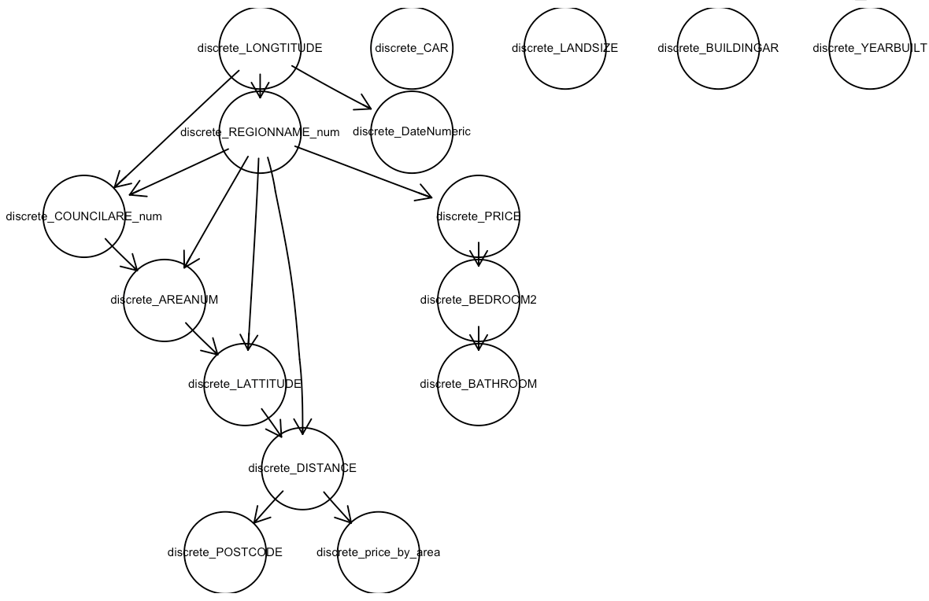

Figure 31 Bayesian Networks graph in house dataset

The dependencies between variables are captured through the directed arcs in Figure 31. The DAG in Figure 31 shows variables like *LONGTITUDE*, *DateNumeric*, and *COUNCILARE_num* (converted to numeric) influence *REGIONNAME_num* (converted to numeric), which, in turn, influences the price of the property. The model includes a derived variable, *price_by_area,* calculated based on the *DISTANCE* variable. *LONGTITUDE*, *LATTITUDE*, *DISTANCE*, and *POSTCODE* variables indicate spatial information, suggesting the model captures geographical aspects of real estate.

**Townhouse**

|  |  |
| --- | --- |
| Variable | Causality |
| ROOMS | 178272.2445 |
| CAR | 118147.6775 |
| BEDROOM2 | 48717.12982 |
| REGIONNAME_num | 38226.60616 |
| METHOD_num | 7439.22981 |
| AREANUM | 6938.74374 |
| COUNClLARE_num | 2591.49344 |
| POSTCODE | 2560.85455 |
| SELLERG_num | 831.10049 |
| DateNumeric | 298.59562 |
| price_by_area | 45.62894 |
| LANDSIZE | 29.45951 |
| ADDRESS_num | 4.83141 |
| PROPERTYCO | 3.86349 |
| DISTANCE | 0 |
| BATHROOM | 0 |
| BUILDINGAR | 0 |
| YEARBUILT | 0 |
| LATTITUDE | 0 |
| LONGTITUDE | 0 |
| SUBURB_num | 0 |

Table 24 Causality of Townhouse Dataset

Among the listed variables, *ROOMS* exhibits the most substantial estimated causal effect on the *PRICE*, with a noteworthy value of approximately 178,272.24. This suggests that the number of rooms significantly influences the property's pricing. Following *ROOMS*, variables such as *CAR*, *BEDROOM2*, *REGIONNAME_num,* and *METHOD_num* demonstrate considerable estimated causal effects on the *PRICE*, indicating their significant impact.

Variables like *AREANUM*, *POSTCODE*, *COUNCILARE_num*, *SELLERG_num*, and *DateNumeric* display moderate estimated causal effects on the *PRICE*, signifying a notable but comparatively lower influence on property pricing. Furthermore*, price_by_area*, *LANDSIZE*, *ADDRESS_num*, and *PROPERTYCO* show relatively lower estimated causal effects on the Price, whereas variables including *DISTANCE*, *BATHROOM*, *BUILDINGAR*, *YEARBUILT*, *LATTITUDE*, *LONGTITUDE*, and *SUBURB_num* demonstrate no observable influence on the *PRICE*, with causality values of 0.

Based on the results obtained from the Markov Blanket analysis for the *price_by_area* variable within the **townhouse** category, 14 variables have been identified that exhibit relationships with *price_by_range* in this specific context. These 5 variables can be considered as either parents’ or children’s nodes in the context of the Bayesian network model for *price_by_area* in the townhouse category. These variables are *DISTANCE*, *LANDSIZE*, *POSTCODE*, *LATTITUDE*, and *REGIONNAME_num*.

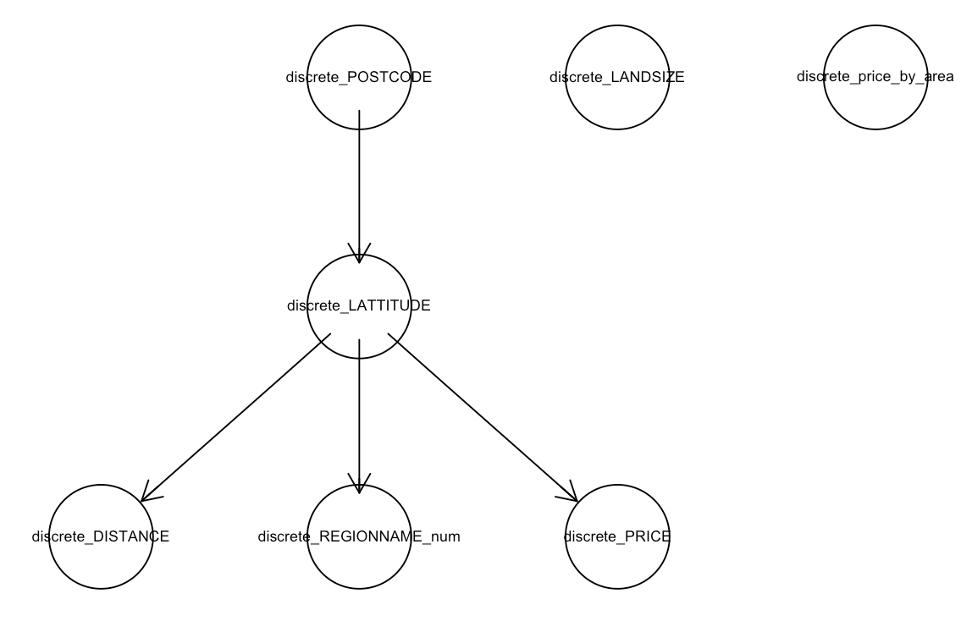

Figure 32 Bayesian Networks in Townhouse Dataset

The dependencies between variables are captured through the directed arcs in Figure 32. DAG in figure 32, shows LATTITUDE is influenced by POSTCODE, indicating a spatial relationship. DISTANCE is influenced by LATTITUDE, suggesting a geographical aspect. The REGIONNAME_num is influenced by LATTITUDE, showing a spatial connection. PRICE is influenced by LATTITUDE, implying a spatial influence on property pricing. The model includes a derived variable, price_by_area, suggesting a calculated variable based on the relationship between property PRICE and LANDSIZE. The presence of LATTITUDE, POSTCODE, and DISTANCE variables suggests a focus on spatial aspects in the model, capturing the geographical distribution of real estate properties.

**Unit**

|  |  |
| --- | --- |
| variable | Causality |
| ROOMS | 155143.0932 |
| CAR | 63220.77756 |
| BEDROOM2 | 52846.37592 |
| METHOD_num | 21460.9173 |
| AREANUM | 4678.786972 |
| REGIONNAME_num | 1120.123543 |
| POSTCODE | 774.266668 |
| COUNCILARE_num | 665.611562 |
| DateNumeric | 169.039132 |
| SELLERG_num | 97.301967 |
| price_by_area | 58.068771 |
| LANDSIZE | 5.906635 |
| ADDRESS_num | 5.550846 |
| PROPERTYCO | 2.667537 |
| DISTANCE | 0 |
| BATHROOM | 0 |
| BUILDINGAR | 0 |
| YEARBUILT | 0 |
| LATTITUDE | 0 |
| LONGTITUDE | 0 |
| SUBURB_num | 0 |

Table 25 Causality of the unit Dataset

Among the variables examined, *ROOMS* demonstrates the most substantial estimated causal effect on the *PRICE*, with an approximate value of 155,143.09. This suggests that the number of rooms significantly influences the property's pricing. Additionally, *DISTANCE*, *BATHROOM*, *BUILDINGAR*, *YEARBUILT*, *LATTITUDE*, *LONGTITUDE*, *SUBURB_num*, and exhibit causal effects of 0, indicating no observable impact on the Price based on this analysis.

Variables such as *POSTCODE*, *BEDROOM2*, *CAR*, *AREANUM*, *METHOD_num*, *COUNCILARE_num*, *REGIONNAME_num*, and *DateNumeric* show estimated causal effects that surpass the established threshold of 134, suggesting their potential influence on property pricing.

Based on the results obtained from the Markov Blanket analysis for the price_by_area variable within the **unit** category, 11 variables have been identified that exhibit relationships with price_by_area in this specific context. These 11 variables can be considered as either parents’ or children’s nodes in the context of the Bayesian network model for price_by_area in the unit category. These variables are BUILDINGAR, ROOMS, POSTCODE, DISTANCE, SUBURB_num, DateNumeric, BATHROOM, REGIONNAME_num, LATTITUDE, METHOD_num, and YEARBUILT.

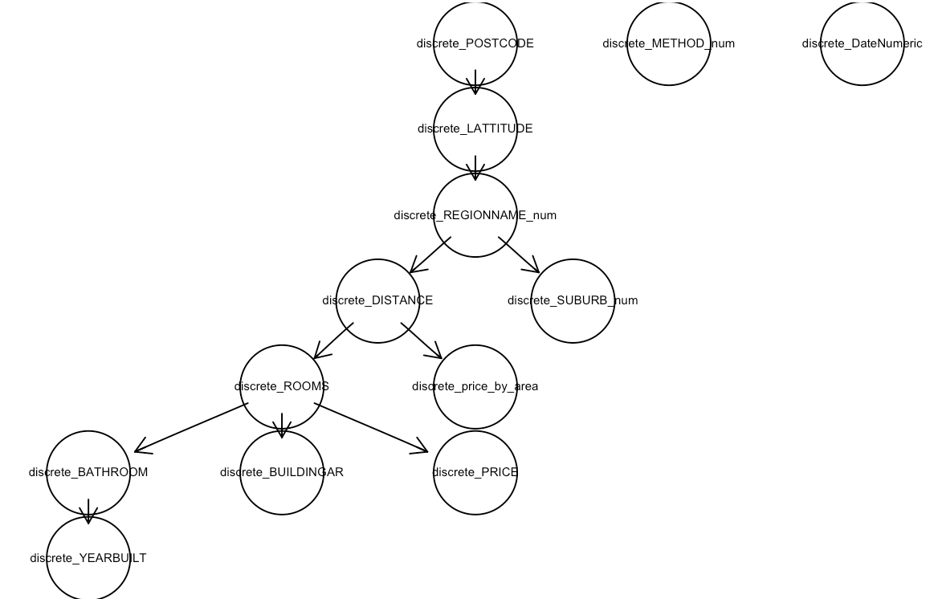

Figure 33 Bayesian Networks in Unit Dataset

The dependencies between variables are captured through the directed arcs in Figure 33. The DAG shows *LATTITUDE* is influenced by *POSTCODE* and *REGIONNAME_num* is influenced by *LATTITUDE*. *DISTANCE* is influenced by *REGIONNAME_num* and, in turn, influences the *SURBURB_num* variable. The number of *ROOMS* influences the number of *BATHROOMS*, *BUILDINGARE_num*, *PRICE*, and *YEARBUILT*. The model includes a derived variable, *price_by_area*, calculated based on the *DISTANCE* variable. Variables like *POSTCODE*, *LATTITUDE*, *REGIONNAME_num*, and *DISTANCE* suggest the incorporation of spatial information. The model captures relationships indicating how the number of rooms influences various property-related characteristics.

|  |  |  |
| --- | --- | --- |
| House dataset | Townhouse dataset | Unit dataset |
| Rooms Region number Bedrooms Cars Area number Postcode Date Land size | Rooms Cars Bedrooms Region number Area number Postcode Date | Rooms Cars Bedrooms Method Area number Region number Postcode |

Table 26 Overview of three datasets Influential Causality

The results from Table 26 indicate that house, townhouse, and unit types exhibit comparable influential causal relationships akin to variables like Rooms, the count of bedrooms and parking spaces, region number, and postcode concerning the physical building area. However, the variable *LANDSIZE* shows an impact, displaying a relatively lesser influential causality primarily towards the house type. Interestingly, this influence diminishes notably when considering townhouse and unit types, displaying no discernible correlation with *LANDSIZE*. This indicates a distinctive trend where *LANDSIZE* appears to hold a secondary or subsidiary influence specifically tied to house type, while its impact on townhouse and unit types seems negligible or non-existent within the causal framework studied.

In summary, a Bayesian Network (BN) functions as a powerful probabilistic graphical model, utilizing a directed acyclic graph to illustrate variables and their conditional dependencies. With nodes representing variables and directed edges indicating probabilistic relationships, **BNs** offer a structured framework. Each node is equipped with a conditional probability distribution, providing insights into the dependencies on parent nodes.

The analysis across three property type datasets—House,Townhouse**,** andUnit—reveals dependencies among variables in real estate. Each dataset's Directed Acyclic Graph (DAG) elucidates distinct relationships: The House dataset emphasizes geographical aspects, associating longitude, latitude, and postcode with property pricing. The townhouse dataset emphasizes spatial connections, displaying how latitude influences price through postcode and distance variables. Unit dataset reveals interrelatedness, indicating how latitude and postcode impact region name and, subsequently, property attributes. Overall, these findings highlight the importance of spatial elements and property characteristics in shaping real estate dynamics across different property types.

## E. Clustering

For clustering the dataset k-means algorithm is used as it is best suitable for numerical data which is dominant in the Melbourne dataset.

Before making clusters, the number of clusters is decided by the elbow method.

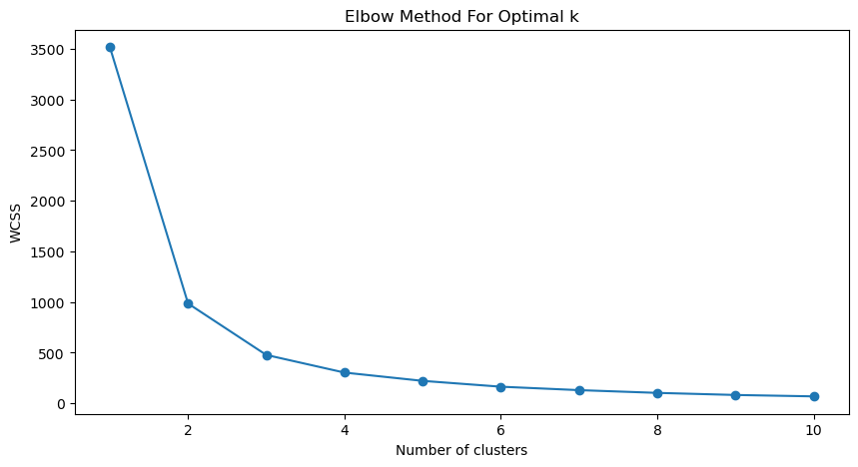

Figure 34 Elbow method for the optimal number of clusters

In Figure 34, the Within-Cluster Sum of Squares (WCSS) is observed to decrease significantly as the number of clusters increases from 1 to 2. This trend of diminishing WCSS indicates an improvement in the model fit. However, post this initial decrease, the rate of reduction in WCSS becomes less pronounced, suggesting the approach of an optimal cluster number.

The elbow point is situated between 2 and 4. Beyond this point, the addition of more clusters does not yield a substantial improvement in the model's performance. So, k=3 is taken as the optimal number of clusters.

Before making the clusters, all the numerical data is standardized so that no one variable can have a disproportionate effect on clustering. Using the K-means algorithm data is clustered into three clusters.

Table 27 shows the statistics of *logpl* which is the log transform of the price of properties by square meter in three different clusters formed.

|  |  |  |  |  |  |  |  |  |
| --- | --- | --- | --- | --- | --- | --- | --- | --- |
| Cluster | count | mean | std | min | 25% | 50% | 75% | max |
| 1 | 1735 | 7.929829 | 0.577303 | 5.56052 | 7.548654 | 7.916097 | 8.306777 | 9.879223 |
| 2 | 2303 | 8.763566 | 0.474099 | 6.137915 | 8.561232 | 8.866377 | 9.052574 | 10.102534 |
| 3 | 1989 | 7.524285 | 0.59309 | 5.064207 | 7.079696 | 7.461757 | 7.963808 | 9.290613 |

Table 27 Log Price by area statistics in three clusters

From these statistics, the following characteristics for each cluster can be inferred:

* **Cluster one** is typified by properties with the lowest average *logpl* values, indicating an association with more affordable housing options. The standard deviation is low, pointing to a smaller variation in property prices within this cluster. This could represent areas with less variability in housing types or sizes.
* **Cluster two** exhibits the highest mean *logpl* values, which implies that properties in this cluster tend to be priced higher than those in the other clusters. The range of *logpl* values is also notably higher, as indicated by the larger standard deviation and the maximum value, which could reflect a diverse mix of high-priced housing, including luxury homes or properties in high-demand urban areas.
* **Cluster three** has mean *logpl* values that are intermediate between Clusters 1 and 2. The standard deviation and the range of *logpl* values are comparable to those of Cluster 1, suggesting a similar degree of price variation to the lower-priced homes but at a higher price point. This cluster might represent a middle-market segment in the property landscape, with a mix of moderately priced homes.

To further understand the characteristics of each cluster the data is visualized for different variables by clusters.

First, the data is plotted on a scatter plot by latitude and longitude to see if specific clusters are situated in specific places.

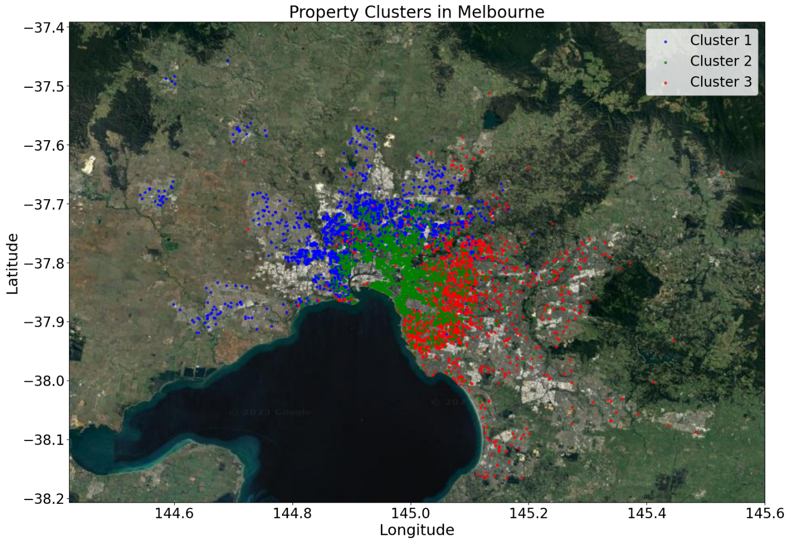

Figure 35 Property clusters in Melbourne

|  |  |  |  |
| --- | --- | --- | --- |
| TYPE | House | Townhouse | Units |
| Cluster |  |  |  |
| 1 | 1761 | 201 | 63 |
| 2 | 797 | 210 | 1318 |
| 3 | 1485 | 159 | 33 |

Table 28 Type of properties in each cluster

Based on the figure 35 and table 28, displaying three property clusters in Melbourne, the following observations can be made:

**Cluster 1 (Blue):** Properties are located mainly in West and North-West areas of Melbourne covering suburbs like Reservoir, Glenroy, Preston, Pascoe Vale, Sunshine West, Essendon, and also in newly developed areas like Wyndham or the city of Hume, etc. There are some new suburban constructions in this area which can be seen by the ratio of the number of houses vs townhouses or units in these areas.

**Cluster 2 (Green):** Properties are located mainly in CBD and suburbs around CBD like Richmond, Brunswick, Port Melbourne, South Melbourne, South Yara, Docklands, etc. There are some high-rise buildings in these areas especially In and around the CBD. Due to that some of the properties in these areas are apartments/units which can be seen in the table showing the highest number of units in this cluster. There are some houses and townhouses in this cluster from suburbs like St Kilda or Kensington.

**Cluster 3 (Red):** Properties are located mainly in the South-East part of metropolitan Melbourne, covering suburbs like Brighton, Hampton, Black Rock, Glen Iris, Camberwell, Surrey Hills, etc. Properties in these areas are large mainly luxurious properties built for leisure or getting beach views. This can be seen in table 28, where houses dominate this cluster and have very few pocket-friendly housing like units or townhouses.

The overlap between clusters in some areas indicates that while there are distinguishing features for each cluster, there is no strict geographical boundary between them.

For gaining more information about specific characteristics of each cluster, the data is now visualized by different important variables like *DISTANCE*, *YEARBUILT*, *ROOMS*, and *BATHROOM*

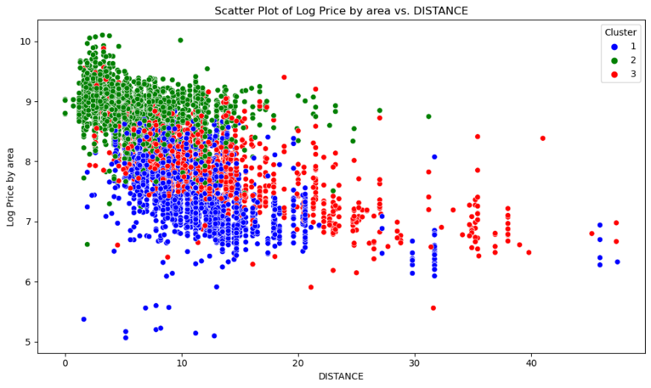

Figure 36 Log Price by area vs DISTANCE by clusters

The mean distance of Cluster 2 seems to be on the lower side when compared to Cluster 1. Cluster one sits somewhere between Cluster 2 and Cluster 3. Both clusters 1 and 3 have properties dispersed at farther distances from the CBD but cluster three has more scattered locations than the other 2 clusters.

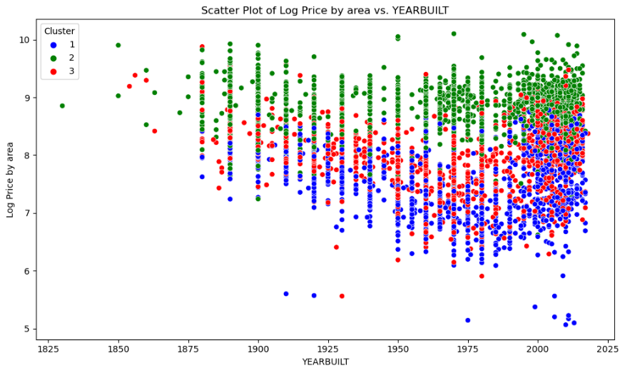

Figure 37 Log Price by area vs YEARBUILT by clusters

*YEARBUILT* does not seem to have much influence on separating clusters other than the part where cluster one does not have any old properties (built before the 1880s). Clusters two and three have some old properties in them showing early settlement took place in those places. Cluster one has a good amount of newly built properties showing new construction taking place in cluster one suburbs,

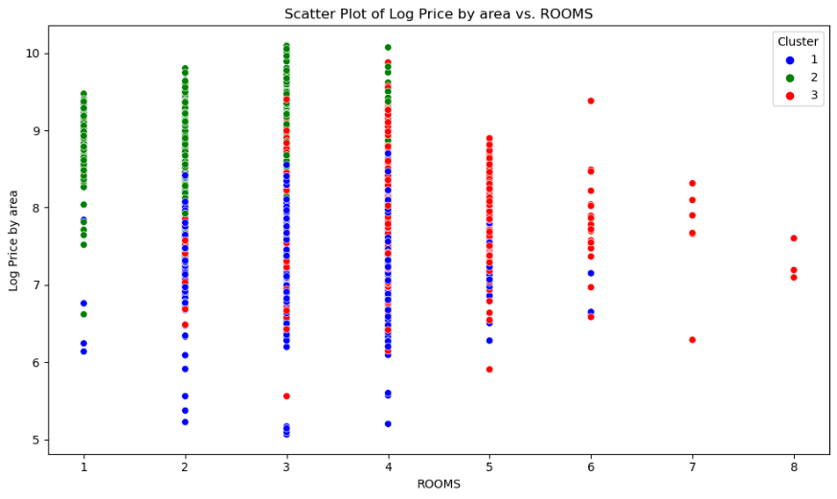

Figure 38 Log Price by area vs ROOMS by clusters

Cluster one has mainly 2, 3, or 4 rooms and is generally priced lower than the other two clusters for the same number of rooms.

Cluster two has mainly 1, 2, or 3 rooms and is generally priced higher than the other two clusters for the same number of rooms. The smaller number of rooms indicates that cluster two has properties that are smaller in size than the other two clusters.

Cluster three has mainly 3,4, 5, or even more rooms and is generally priced somewhere in between the other two clusters for the same number of rooms. The larger number of rooms indicates that cluster three has properties that are larger than the other two clusters.

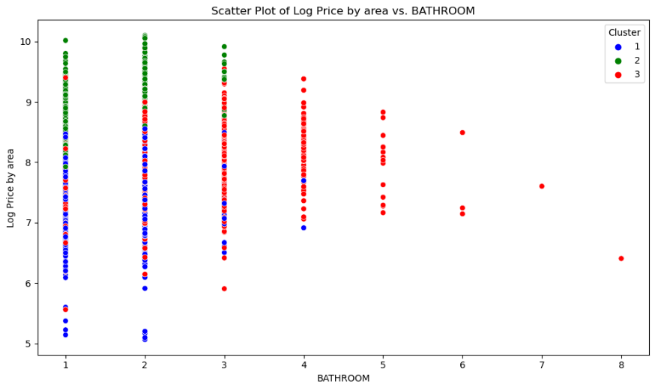

Figure 39 Log Price by area vs BATHROOM by clusters

Bathrooms indicate a similar trend as the number of rooms.

Cluster one has a similar number of bathrooms to Cluster two, but the properties are priced lower than the other two clusters. On average, although Cluster one has more rooms than Cluster two it has a somewhat similar number of bathrooms, showing budget-oriented construction has been done here.

Cluster two has mainly 1, 2, or 3 bathrooms and is generally priced higher than the other two clusters for the same number of rooms.

Cluster three has mainly 3,4, 5, or even more bathrooms and is generally priced somewhere in between the other two clusters for the same number of bathrooms. This is in line with the number of rooms this cluster has.

Detailed characteristics of many variables by clusters are shown in table 29:

|  |  |  |  |  |  |  |  |  |
| --- | --- | --- | --- | --- | --- | --- | --- | --- |
|  | **DISTANCE** | | | | **BATHROOM** | | | |
| **Cluster** | **mean** | **std** | **min** | **max** | **mean** | **std** | **min** | **max** |
| **1** | 11.20281 | 4.783958 | 1.6 | 47.4 | 1.516543 | 0.585436 | 1 | 4 |
| **2** | 6.516 | 3.693439 | 0 | 31.2 | 1.219785 | 0.437432 | 1 | 3 |
| **3** | 12.7455 | 6.426555 | 1.6 | 47.3 | 2.143709 | 0.806583 | 1 | 8 |
|  | **ROOMS** | | | | **CAR** | | | |
| **Cluster** | **mean** | **std** | **min** | **max** | **mean** | **std** | **min** | **max** |
| **1** | 3.163457 | 0.651426 | 1 | 6 | 1.809877 | 0.947172 | 0 | 8 |
| **2** | 2.143656 | 0.64938 | 1 | 4 | 1.013333 | 0.550616 | 0 | 3 |
| **3** | 3.781157 | 0.808179 | 2 | 8 | 2.076923 | 0.941954 | 0 | 10 |
|  | **price_by_area** | | | | **LANDSIZE** | | | |
| **Cluster** | **mean** | **std** | **min** | **max** | **mean** | **std** | **min** | **max** |
| **1** | 2046.446 | 1163.348 | 158.2549 | 7272.727 | 559.3462 | 1001.413 | 0 | 37000 |
| **2** | 7259.402 | 2665.976 | 749.0809 | 24404.76 | 319.4039 | 984.9482 | 0 | 21715 |
| **3** | 3140.213 | 1807.692 | 259.9581 | 19520.55 | 617.4347 | 364.0372 | 0 | 9838 |
|  | **BUILDINGAR** | | | | **PROPERTYCO** | | | |
| **Cluster** | **mean** | **std** | **min** | **max** | **mean** | **std** | **min** | **max** |
| **1** | 143.9742 | 60.14057 | 3 | 934 | 6880.767 | 4818.519 | 389 | 21650 |
| **2** | 91.14391 | 34.17975 | 3 | 307 | 8291.364 | 4401.376 | 438 | 21650 |
| **3** | 211.0917 | 119.198 | 3 | 3112 | 6932.278 | 3333.296 | 534 | 21650 |

Table 29 Variable stats of different variables in different clusters

The observed characteristics of each cluster are:

**Cluster 1 Characteristics**

* Distance: Properties are moderately far from the city centre (mean ~11.2 km), suggesting a suburban setting.
* Bathrooms: Average of 1.5 bathrooms per property, indicating standard residential properties.
* Rooms: An average of 3.2 rooms signifies moderately sized family homes.
* Building Area: The average building area of ~144 sqm aligns with medium-sized residential properties.
* Car Spaces: Adequate parking facilities, possibly indicating a family-oriented demographic.
* Property Count: Reflects a moderately populated area with a diverse range of properties.
* Price by area: Shows moderately priced properties compared to Cluster 2 and 3, indicating that while these are family-sized homes, they offer a more affordable square meter rate, aligning with the expectations for suburban living spaces.

**Cluster 2 Characteristics**

* Distance: Closer to the city centre (mean ~6.5 km), likely indicating urban or inner-suburban areas.
* Bathrooms: Fewer bathrooms (mean ~1.2), common in smaller apartments or townhouses.
* Rooms: Fewer rooms (mean ~2.1), suggesting smaller units or apartments, suitable for singles or small families.
* Building Area: Smaller average building area of ~91 sqm, typical of apartments or small townhouses.
* Car Spaces: Limited parking is a common feature in urban settings.
* Property Count: A high property count could indicate a densely populated area with high-rise buildings or compact living spaces.
* Price by area: Shows remarkably high price by square meter. This is typical for city properties where space is at a premium, and even smaller units can command higher prices per square meter due to the desirable location.

**Cluster 3 Characteristics**

* Distance: Similar distance from the city centre as Cluster 0 (mean ~12.7 km), indicating suburban locations.
* Bathrooms: More bathrooms (mean ~2.1), suggesting larger family homes or luxury properties.
* Rooms: A higher number of rooms (mean ~3.8), typical of larger family homes.
* Building Area: Large average building area (~211 sqm), indicating spacious homes or luxury residences.
* Car Spaces: Ample parking, aligning with family or luxury homes.
* Property Count: Reflects a less densely populated area, possibly with larger plots and more spacious surroundings.
* Price by area: Shows a high *price_by_area* due to the larger, more luxurious homes that are spacious and come with additional amenities.

**Comparison and Conclusion**

Proximity to the City Centre and Property Size

Cluster one represents the suburban ideal with a focus on medium-sized family homes that are moderately priced for a given size. They are located at farther distances from the CBD and are mainly situated on the left side of Melbourne. The cluster has a good amount of newly constructed properties showing new developments.

Cluster two is characterized by its proximity to the city centre, making it ideal for those who value convenience and easy access to work and urban amenities. This cluster is defined by its high number of compact living spaces, such as units and small townhouses. These properties being closer to the city command the highest prices for a given area. There is a healthy number of small properties in this area suggesting there are high-rise buildings containing apartments.

Cluster three is marked by larger, more luxurious properties, often with expansive lots and additional amenities which demand higher prices for a given area than Cluster 1. These properties are mainly located at the farthest distance from CBD among all clusters and towards the southern beaches of Melbourne.

**Conclusion**

The three clusters represent distinct segments within Melbourne's housing market, each with unique attributes appealing to different lifestyle preferences and family sizes:

Cluster 1: Suburban family homes, offering a balance between space and proximity to the city, suitable for a wide range of families.

Cluster 2: Urban, high-density apartments and townhouses, attract those who prioritize central living, such as young professionals or those with smaller space requirements.

Cluster 3: Spacious and luxurious suburban homes, catering to those seeking larger living spaces, privacy, and a higher standard of living, possibly with greater financial means.

# 5. Summary of Results

The analysis of Melbourne's real estate market using diverse modelling approaches reveals insights into the factors influencing property prices. Across Regression, Classification, Time Series, Bayesian Networks, and Clustering models, several common themes emerge, with some notable variations. The Regression model underscores the paramount importance of proximity to the city centre, property type, and geographic location (latitude and longitude) in determining property prices. Interestingly, these factors are echoed in the Bayesian Networks' emphasis on geographical aspects and the Clustering model also describes properties based on proximity to the CBD and property size. This congruence across models highlights the universal real estate mantra of "location, location, location" in Melbourne's market.

The Time Series model, with its focus on forecasting accuracy, complements these findings by quantifying prediction errors (MAE, RMSE, MAPE), showing that predictions are generally close to actual prices with an average deviation of around 4%. This aligns with the Regression model's insights on the importance of newer properties and specific features like car parking space, suggesting a dynamic market responsive to modern amenities and lifestyle preferences. On the other hand, the Classification models (Decision Tree and KNN) applied to different housing data subsets (House, Unit, Townhouse) reveal variances in model performance, with KNN generally outperforming the Decision Tree. This indicates the effectiveness of specific modelling techniques in capturing the nuances of various housing types.

Overall, these models collectively paint a comprehensive picture of the Melbourne real estate market. These underscore the critical role of location (proximity to the city centre and geographic coordinates), property type, and specific features (like year built and car space) in shaping property values. This combination of findings from different analytical perspectives provides a multi-dimensional view of the market, beneficial for stakeholders ranging from individual buyers and sellers to market strategists and urban planners. The congruence and variations in the models' results not only affirm the complexity of real estate valuation but also the results of diverse analytical approaches in highlighting market trends.

# References

Bielza, C. & Larranaga, P., 2014. Discrete Bayesian network classifiers: A survey. *ACM Computing Surveys (CSUR),* pp. 1-43.

Breiman, L., 2001. Random forests. *Machine learning,* Volume 45, pp. 5-32.

Carranza, E. J. M. & Laborte, A. G., 2015. Random forest predictive modeling of mineral prospectivity with small number of prospects and data with missing values in Abra (Philippines). *Computers & geosciences,* Volume 74, pp. 60-70.

Cortes, C. & Vapnik, V., 1995. Support-vector networks. *Machine Learning,* Volume 20, pp. 273-297.

Crawford, G. &. F., 2003. Assessing the Forecasting Performance of Regime-Switching, ARIMA and GARCH Models of House Prices. *Real Estate Economics,* Volume 31, pp. 223-243.

Darwiche, A., 2008. *Bayesian networks.* s.l.:Foundations of Artificial Intelligence.

Draper, N. R. a. & Smith, H., 1998. *Applied regression analysis.* s.l.:Hoboken, New Jersey : John Wiley & Sons, Inc..

Elith, J. & Leathwick, J., 2011. *Boosted Regression Trees for ecological modeling.* [Online]   
Available at: https://cran. r-project. org/web/packages/dismo/vignettes/brt.pdf

Gislason, P. O., Benediktsson, J. A. & Sveinsson, J. R., 2006. Random Forests for land cover classification. *Pattern recognition letters,* Volume 27, pp. 294-300.

Haggstrom, J., 2018. Data‐driven confounder selection via Markov and Bayesian networks. *Biometrics,* Volume 74, pp. 389-398.

Hindmarsh, A., 2000. The PVODE and IDA algorithms. *Lawrence Livermore National Lab.(LLNL), Livermore, CA (United States)..*

Jadevicius, A. & Huston, S., 2015. ARIMA modelling of Lithuanian house price index. *International Journal of Housing Markets and Analysis,* Volume 8, pp. 135-147.

Jiao, W. Y., 2017. Housing Price prediction Using Support Vector Regression. *Master's Projects,* pp. 540-.

Julia, N.-T. . M., José, C. M. & Francisco, R. J., 2013. Artificial Neural Networks for Predicting Real Estate Prices. *Revista de métodos cuantitativos para la economía y la empresa,* Volume 15, pp. 29-44.

Lam, D., Wei, M. & Wunsch, D., 2015. Clustering Data of Mixed Categorical and Numerical Type With Unsupervised Feature Learning. *IEEE Access,* Volume 3, pp. 1605-1613.

Myles, A., Feudale, R., Liu, Y. & Woody, N., 2004. An introduction to decision tree modeling. *Journal of Chemometrics: A Journal of the Chemometrics Society,* Volume 18, pp. 275-285.

Neapolitan, E. & Morris, S., 2004. *Probabilistic modelling with bayesian networks..* s.l.:The SAGE handbook of quantitative methodology for the social sciences.

Patricio Cerda, G. V. B. K., 2018. Similarity encoding for learning with dirty categorical variables. *arXiv,* Volume 1806.00979.

Samruddhi, K. & Kumar, R., 2020. Used car price prediction using k-nearest neighbor based model. *Int. J. Innov. Res. Appl. Sci. Eng.(IJIRASE),* Volume 271, pp. 629-632.

Song, Y. & Ying, L., 2015. Decision tree methods: applications for classification and prediction. *Shanghai archives of psychiatry,* Volume 27, pp. 130-135.

Syakur, M. A., Khotimah, B. K., Rochman, E. M. S. & Satoto, B. D., 2018. Integration K-Means Clustering Method and Elbow Method For Identification of The Best Customer Profile Cluster. *IOP Conference Series: Materials Science and Engineering,* 336(1), pp. 12017-.

Toothaker, L. E., Aiken, L. S. & West, S. G., 1994. Multiple Regression: Testing and Interpreting Interactions. *The Journal of the Operational Research Society,* Volume 45, pp. 119-.

Tsagris, M., 2019. Bayesian network learning with the PC algorithm: an improved and correct variation. *Applied Artificial Intelligence,* Volume 33, pp. 101-123.

Xiaojie, X. & Yun, Z., 2021. House price forecasting with neural networks. *Intelligent systems with applications,* Volume 12, pp. 200052-.

Yunneng, Q., 2020. A new stock price prediction model based on improved KNN. *In 2020 7th International Conference on Information Science and Control Engineering (ICISCE) IEEE,* pp. 77-80.